



8-Bit Microprocessor

Digital Design using FPGA – Final Project

Under Supervision of : Prof. Mohamed Youssef

Mohaned Waled Hosny Ibrahim

Muhammad Sameer Abdelhamid

15th August 2025

# **Abstract**

This report documents the complete design, implementation, and verification of a custom 8-bit, single-cycle microprocessor. The primary objective was to apply computer architecture principles to create a functional CPU model from the ground up using the VHDL hardware description language. A modular, bottom-up methodology was employed, beginning with the development of individual components such as a 16-function Arithmetic Logic Unit (ALU), an 8x8 register file, and a control unit. The final architecture is based on a custom 16-bit, register-to-register Instruction Set Architecture (ISA). A critical design challenge, the Read-After-Write (RAW) data hazard inherent in single-cycle designs, was identified and resolved through the implementation of a data forwarding path. The fully integrated microprocessor was rigorously tested in simulation, where it successfully executed a multi-line test program, with final waveform results precisely matching the expected execution trace. The project concludes with a functional and verifiable VHDL model of an 8-bit microprocessor, providing a robust foundation for future enhancements such as data memory, conditional branching, and pipelining.

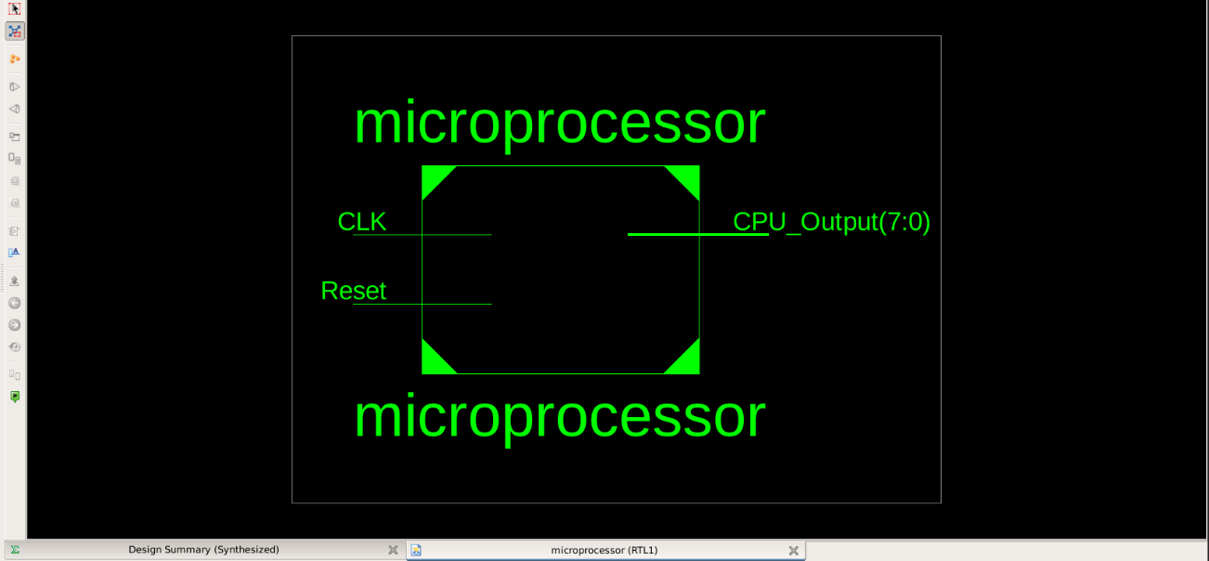

Table of Contents

*Abstract 1*

*1.0 Introduction 3*

*1.1 Project Overview 3*

*1.2 Objectives 3*

*1.3 Scope and Limitations 3*

*1.4 Report Structure 4*

*2.0 Theoretical Background 5*

*2.1 CPU Architecture Fundamentals 5*

*2.2 Datapath and Control Path 5*

*2.3 Hardware Description Language (HDL) 6*

*3.0 Microprocessor Architecture and Design 6*

*3.1 High-Level Architecture 6*

*3.2 Instruction Set Architecture (ISA) 7*

*3.3 Opcode Mapping 7*

*3.4 Data Hazard and Forwarding 8*

*4.0 Modular Implementation (VHDL) 9*

*4.1 Arithmetic Logic Unit (ALU) 9*

*4.2 Register File 14*

*4.3 Program Counter (PC) 15*

*4.4 Instruction Memory (ROM) 17*

*4.5 Status Register 18*

*4.6 Control Unit 20*

*4.7 Top-Level Integration 22*

*5.0 Verification and Testing 25*

*5.1 Simulation Strategy 25*

*5.2 Component-Level Simulation 25*

*5.2.1 Arithmetic Logic Unit (ALU) 26*

*5.2.2 Register File 27*

*5.2.3 Instruction Memory (ROM) 28*

*5.2.4 Program Counter (PC) 29*

*5.2.5 Status Register 30*

*5.2.6 Control Unit 31*

*5.3 Top-Level System Simulation 32*

*6.0 Discussion and Challenges 33*

*6.1 Analysis of Results 33*

*6.2 Key Challenges and Solutions 33*

*6.3 Design Trade-offs 33*

*7.0 Conclusion and Future Work 35*

*7.1 Conclusion 35*

*7.2 Future Work and Enhancements 35*

*References 36*

# **1.0 Introduction**

## **1.1 Project Overview**

The study of computer architecture provides the theoretical foundation for how modern processors work, yet a comprehensive understanding is best achieved through practical application. This project bridges the gap between theory and practice by documenting the design, implementation, and verification of a custom 8-bit microprocessor. Using the VHDL hardware description language, a complete central processing unit (CPU) was constructed from the ground up, following a modular, bottom-up design methodology. The final result is a functional, single-cycle microprocessor model capable of executing a defined set of arithmetic and logical instructions, serving as a tangible demonstration of core computer engineering principles.

## **1.2 Objectives**

The primary goal of this project was divided into the following specific objectives:

* **Design a custom 8-bit Instruction Set Architecture (ISA):** Define a fixed-length, 16-bit instruction format to support 16 unique register-to-register operations, including arithmetic, logical, and shift/rotate functions.
* **Implement Core Hardware Modules in VHDL:** Develop and individually verify all essential hardware components, including a multi-function Arithmetic Logic Unit (ALU), an 8x8 register file, a program counter, status register, instruction memory, and a combinational control unit.
* **Integrate Modules into a Cohesive System:** Assemble all verified modules into a top-level, single-cycle datapath architecture, complete with the necessary control logic and internal buses to ensure correct data flow and operation.
* **Verify the Complete Microprocessor Design:** Perform a comprehensive system-level simulation to validate the microprocessor's ability to correctly fetch, decode, and execute a multi-line test program, verifying the final output against a predicted execution trace.

## **1.3 Scope and Limitations**

To ensure the project remained focused and achievable, the following scope was defined:

* **In Scope:**
  + **Architecture:** A single-cycle processor where each instruction completes in one clock cycle.
  + **Instruction Set:** A set of 16 register-to-register instructions.
  + **Data Path:** An 8-bit data path width.
  + **Hazard Handling:** Implementation of a data forwarding path to resolve Read-After-Write (RAW) data hazards.
  + **Verification:** The design is verified exclusively through simulation.
* **Out of Scope:**
  + **Memory Interface:** The design does not include a separate data memory (RAM) or the corresponding LOAD/STORE instructions.
  + **Control Flow:** Advanced control flow instructions such as conditional branches, jumps, and subroutines (requiring a stack) are not implemented.
  + **Advanced Features:** The architecture does not include pipelining, interrupt handling, or external I/O interfaces.

## **1.4 Report Structure**

This report is structured to logically present the design process from conception to verification. Section 2, the next section provides the theoretical background on CPU architecture and VHDL.

Section 3 details the high-level design of the microprocessor, including its custom ISA. Section 4 presents the VHDL implementation of each individual hardware module. Section 5 documents the verification strategy and presents the final simulation results. Finally, Sections 6 and 7 discuss the challenges encountered during the project and offer a conclusion on the work accomplished, along with potential directions for future enhancements.

# **2.0 Theoretical Background**

## **2.1 CPU Architecture Fundamentals**

A Central Processing Unit (CPU) is the primary component of a computer that executes instructions. Its design is governed by a set of architectural principles that dictate how it operates. Most processor designs are based on one of two fundamental models: **Von Neumann** or **Harvard**. The Von Neumann architecture uses a single, shared memory and a common bus for both instructions and data. In contrast, the Harvard architecture uses physically separate memories and buses for instructions and data, allowing simultaneous access to both and potentially higher performance. This project's design more closely resembles a **Harvard** architecture, as it utilizes a dedicated Instruction Memory.

Regardless of the model, all processors operate on a fundamental loop known as the **Fetch-Decode-Execute cycle**.

This three-step process is the basis for all program execution:

1. **Fetch:** The processor retrieves the next instruction from memory. The address of this instruction is supplied by a special register called the Program Counter (PC).
2. **Decode:** The fetched instruction, represented as a binary number, is interpreted by the Control Unit to determine which operation is to be performed and which data to use.
3. **Execute:** The operation is carried out by the appropriate components. This may involve a calculation in the Arithmetic Logic Unit (ALU), a data movement between registers, or a change in the program flow. Once complete, the cycle repeats.

## **2.2 Datapath and Control Path**

A microprocessor's internal architecture can be logically divided into two distinct parts: the datapath and the control path.

* The **Datapath** can be thought of as the "muscles" of the CPU. It comprises all the hardware components that hold, process, and move data. In this project, the datapath includes the **Arithmetic Logic Unit (ALU)**, the **Register File**, the **Program Counter (PC)**, and the internal buses that connect them. Its primary function is to perform the operations specified by the instructions.
* The **Control Path** is the "brain" of the CPU. Its core is the **Control Unit**, which is responsible for directing the datapath's activities. By decoding the current instruction, the control path generates a series of command signals that tell the datapath components what to do in a given cycle—for example, which operation the ALU should perform, which registers to read from, and whether to write a result back.

## **2.3 Hardware Description Language (HDL)**

This microprocessor was designed using VHDL (VHSIC Hardware Description Language). Unlike traditional software programming languages that describe a sequence of steps, an HDL is used to describe the structure and behavior of electronic hardware. The most critical distinction is **concurrency**; in VHDL, most operations are modeled as occurring simultaneously, just as they would in a physical circuit with millions of transistors operating in parallel.

VHDL serves three primary purposes in the digital design workflow:

1. **Design:** It provides a precise, text-based method for defining the logic of each hardware module.
2. **Simulation:** It allows for the creation of testbenches to rigorously verify the correctness of the design before it is physically created.
3. **Synthesis:** VHDL code can be compiled by a synthesis tool, which automatically translates the hardware description into a netlist of logic gates and interconnections that can be implemented on a physical device, such as a Field-Programmable Gate Array (FPGA). This project focuses on the design and simulation stages.

# **3.0 Microprocessor Architecture and Design**

## **3.1 High-Level Architecture**

The microprocessor is designed as a **single-cycle** machine, where each instruction is fully executed in one clock cycle. This approach simplifies the control logic significantly. The architecture consists of five primary, interconnected functional blocks: the Program Counter (PC), Instruction Memory, Register File, Arithmetic Logic Unit (ALU), and Control Unit.

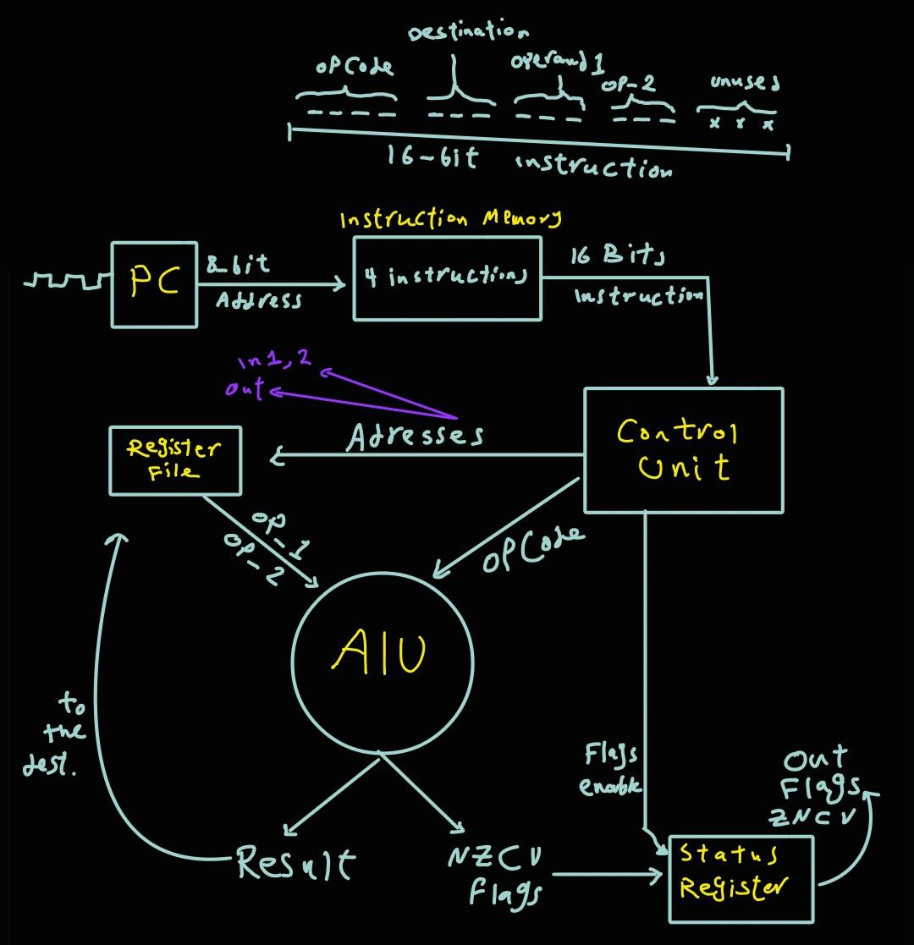The data flow for a single instruction is as follows:

1. The **Program Counter** provides an 8-bit address to the **Instruction Memory**.
2. The **Instruction Memory** outputs the corresponding 16-bit instruction.
3. The instruction is sent to the **Control Unit** for decoding and to the **Register File** to select source operands.
4. The **Register File** outputs the two 8-bit source operands to the **ALU**.
5. The **Control Unit** sends a 4-bit opcode to the **ALU**, which performs the specified operation.
6. The 8-bit result from the ALU is written back to the **Register File**.

## **3.2 Instruction Set Architecture (ISA)**

The Instruction Set Architecture (ISA) defines the interface between the software (the program) and the hardware. A custom 16-bit, fixed-length ISA was developed for this project, based on a simple **Register-to-Register (R-Type)** format. This means that ALU operations are performed on data held in registers, and the result is stored in a register.

The 16-bit instruction word is partitioned into the following fields:

|  |  |  |  |  |  |
| --- | --- | --- | --- | --- | --- |
| Bits | 15 14 13 12 | 11 10 9 | 8 7 6 | 5 4 3 | 2 1 0 |
| Purpose | **Opcode** | **Dest. Reg (Rd)** | **Source Reg 1 (Rs1)** | **Source Reg 2 (Rs2)** | Unused |
| Size | 4 bits | 3 bits | 3 bits | 3 bits | 3 bits |

* **Opcode:** Specifies the operation to be performed by the ALU.
* **Rd (Destination Register):** The 3-bit address of the register where the result will be stored.
* **Rs1 (Source Register 1):** The 3-bit address of the first source operand.
* **Rs2 (Source Register 2):** The 3-bit address of the second source operand.

## **3.3 Opcode Mapping**

The 4-bit opcode field allows for 24=16 unique instructions. The mapping from the binary opcode to the instruction mnemonic is defined below.

|  |  |  |
| --- | --- | --- |
| Opcode | Mnemonic | Description |
| 0000 | ADD | Add Rs1 and Rs2, store in Rd |
| 0001 | SUB | Subtract Rs2 from Rs1, store in Rd |
| 0010 | MUL | Multiply Rs1 and Rs2, store in Rd |
| 0011 | GT | If Rs1 > Rs2, store 1 in Rd, else 0 |
| 0100 | LT | If Rs1 < Rs2, store 1 in Rd, else 0 |
| 0101 | EQ | If Rs1 = Rs2, store 1 in Rd, else 0 |
| 0110 | AND | Bitwise AND Rs1 and Rs2, store in Rd |
| 0111 | OR | Bitwise OR Rs1 and Rs2, store in Rd |
| 1000 | XOR | Bitwise XOR Rs1 and Rs2, store in Rd |
| 1001 | NOT | Bitwise NOT Rs1, store in Rd |
| 1010 | INC | Increment Rs1, store in Rd |
| 1011 | DEC | Decrement Rs1, store in Rd |
| 1100 | LSL | Logical Shift Left Rs1, store in Rd |
| 1101 | LSR | Logical Shift Right Rs1, store in Rd |
| 1110 | ROL | Rotate Left Rs1, store in Rd |
| 1111 | ROR | Rotate Right Rs1, store in Rd |

## **3.4 Data Hazard and Forwarding**

A critical challenge in any processor design is the **data hazard**, specifically the Read-After-Write (RAW) hazard. This occurs when an instruction attempts to read a register's value before a preceding instruction has finished writing its new value back to that register.

For example, in the sequence:

1. ADD R3, R1, R2
2. SUB R4, R3, R1

The SUB instruction needs the new value of R3 calculated by ADD. In our clocked design, the ADD result is only written to R3 on the rising clock edge that begins the *next* cycle. The SUB instruction, however, needs to *read* from R3 at the start of that same cycle. This timing conflict would cause the SUB to read the old, stale value of R3, leading to an incorrect result.

The architectural solution implemented to solve this is **Data Forwarding** (also known as bypassing). Instead of waiting for the data to be written to and then read back from the Register File, a bypass path is created. This path forwards the ALU's result from the end of one instruction's execution directly back to the ALU's input for the very next instruction, ensuring the most current data is always used. This was implemented in the top-level VHDL using combinational logic that functions as a multiplexer ahead of the ALU's inputs.

Of course. Here is the complete Section 4.0, with all the subsections combined and placeholders added for your VHDL code snapshots.

# **4.0 Modular Implementation (VHDL)**

This section details the VHDL implementation of each major hardware module of the microprocessor. A consistent bottom-up design and verification strategy was employed, ensuring each component was functional before its integration into the top-level design.

## **4.1 Arithmetic Logic Unit (ALU)**

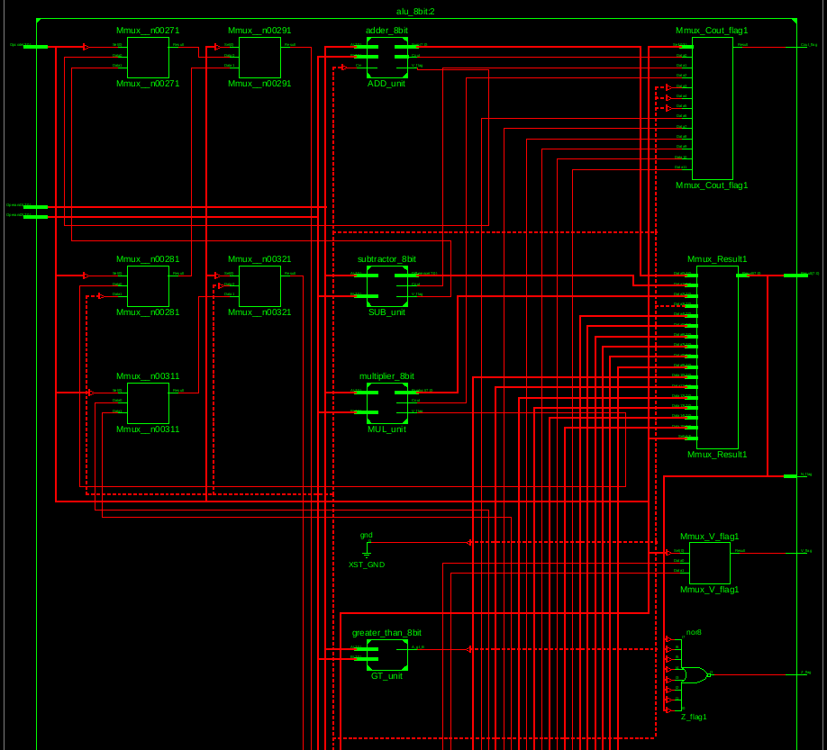The Arithmetic Logic Unit (ALU) is the computational core of the microprocessor. It is a **combinational circuit** designed to perform the 16 distinct arithmetic and logical operations defined by the Instruction Set Architecture. The specific operation to be executed is determined by the **4-bit ALU Opcode** signal from the Control Unit. The ALU takes two 8-bit operands as input and produces an 8-bit result, along with four status flags (Negative, Zero, Carry, Overflow) that describe the outcome of the operation.

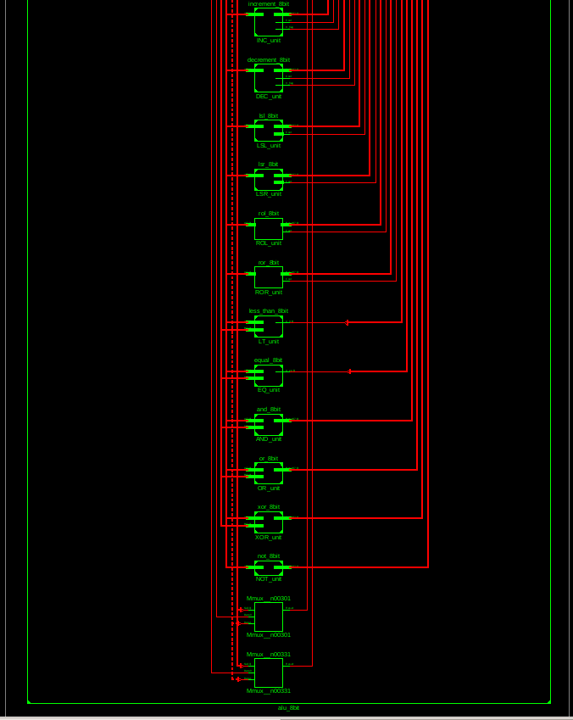

To manage complexity and facilitate testing, the ALU was not designed as a single monolithic block. Instead, it was constructed using a **modular design** approach, where individual functional units were developed and verified independently before being integrated into the final ALU entity.

The key sub-components of the ALU are described below:

* 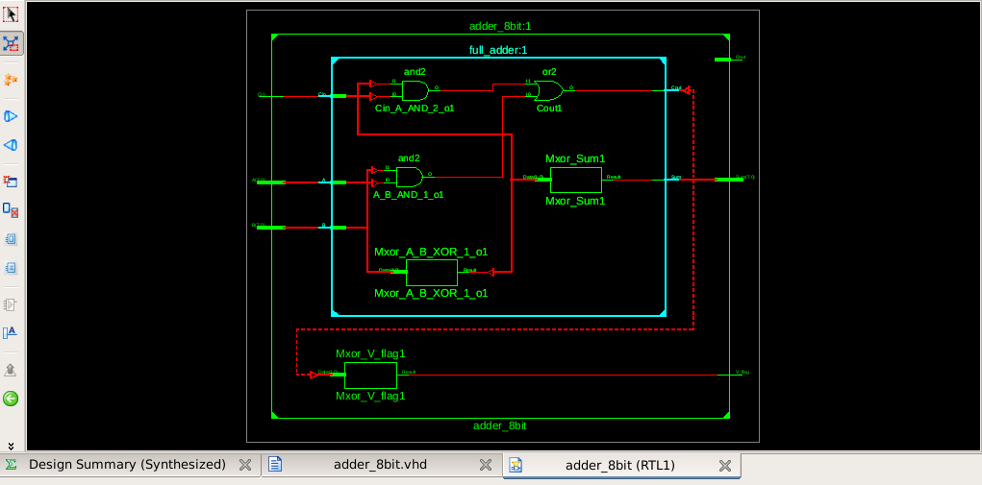**Adder (adder_8bit):** This unit performs 8-bit binary addition. It was implemented structurally as a **ripple-carry adder**, composed of eight instances of a fundamental full_adder component. This block is responsible for generating the primary Carry (Cout) and Overflow (V_flag) flags for addition-based operations.
* 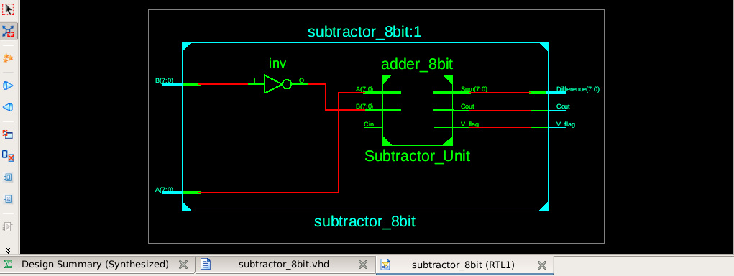**Subtractor (subtractor_8bit):** To promote hardware reuse, a dedicated subtractor was not created. Instead, subtraction is performed using the adder via the **two's complement** method. The operation A - B is implemented as A + not(B) + 1, which involves inverting the second operand and setting the adder's carry-in bit to '1'.
* 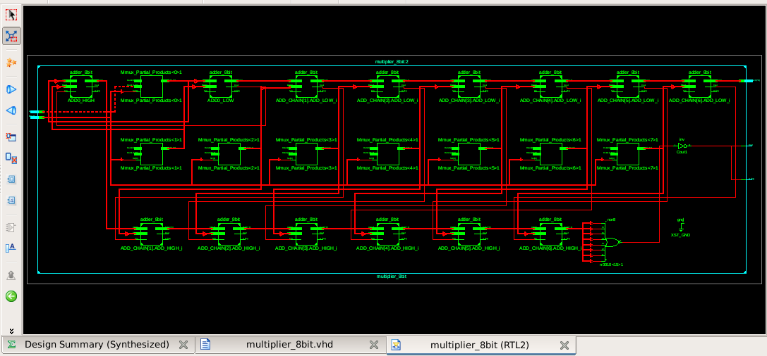**Multiplier (multiplier_8bit):** This is the most complex arithmetic unit. It was implemented structurally using a chain of adders to sum an array of shifted partial products. The full 16-bit mathematical result is truncated to the lower 8 bits for the final output, with the upper 8 bits used to set the Carry and Overflow flags if the result exceeds 255.
* **Comparators (greater_than_8bit, less_than_8bit, equal_8bit):**

These units were built structurally using a cascading design. A single, reusable compare_1bit slice was designed and then instantiated eight times to create a full 8-bit comparator for each condition.

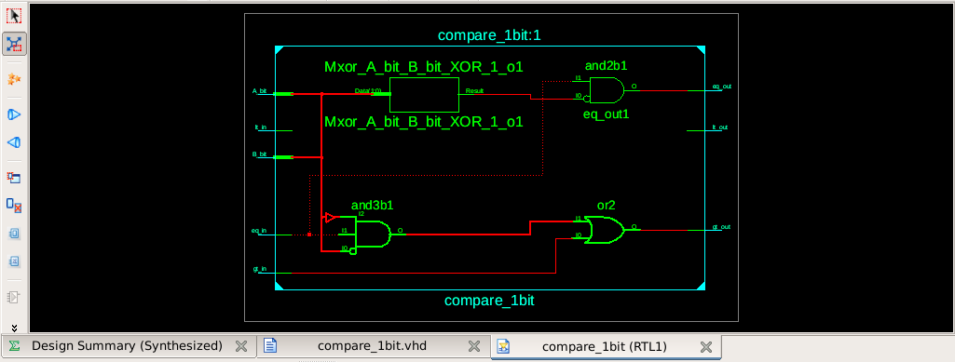

* **Logical and Shift Units:** Simpler operations such as AND, OR, XOR, NOT, and all shift/rotate functions were implemented as simple behavioral VHDL entities, as their logic does not require complex structural decomposition.

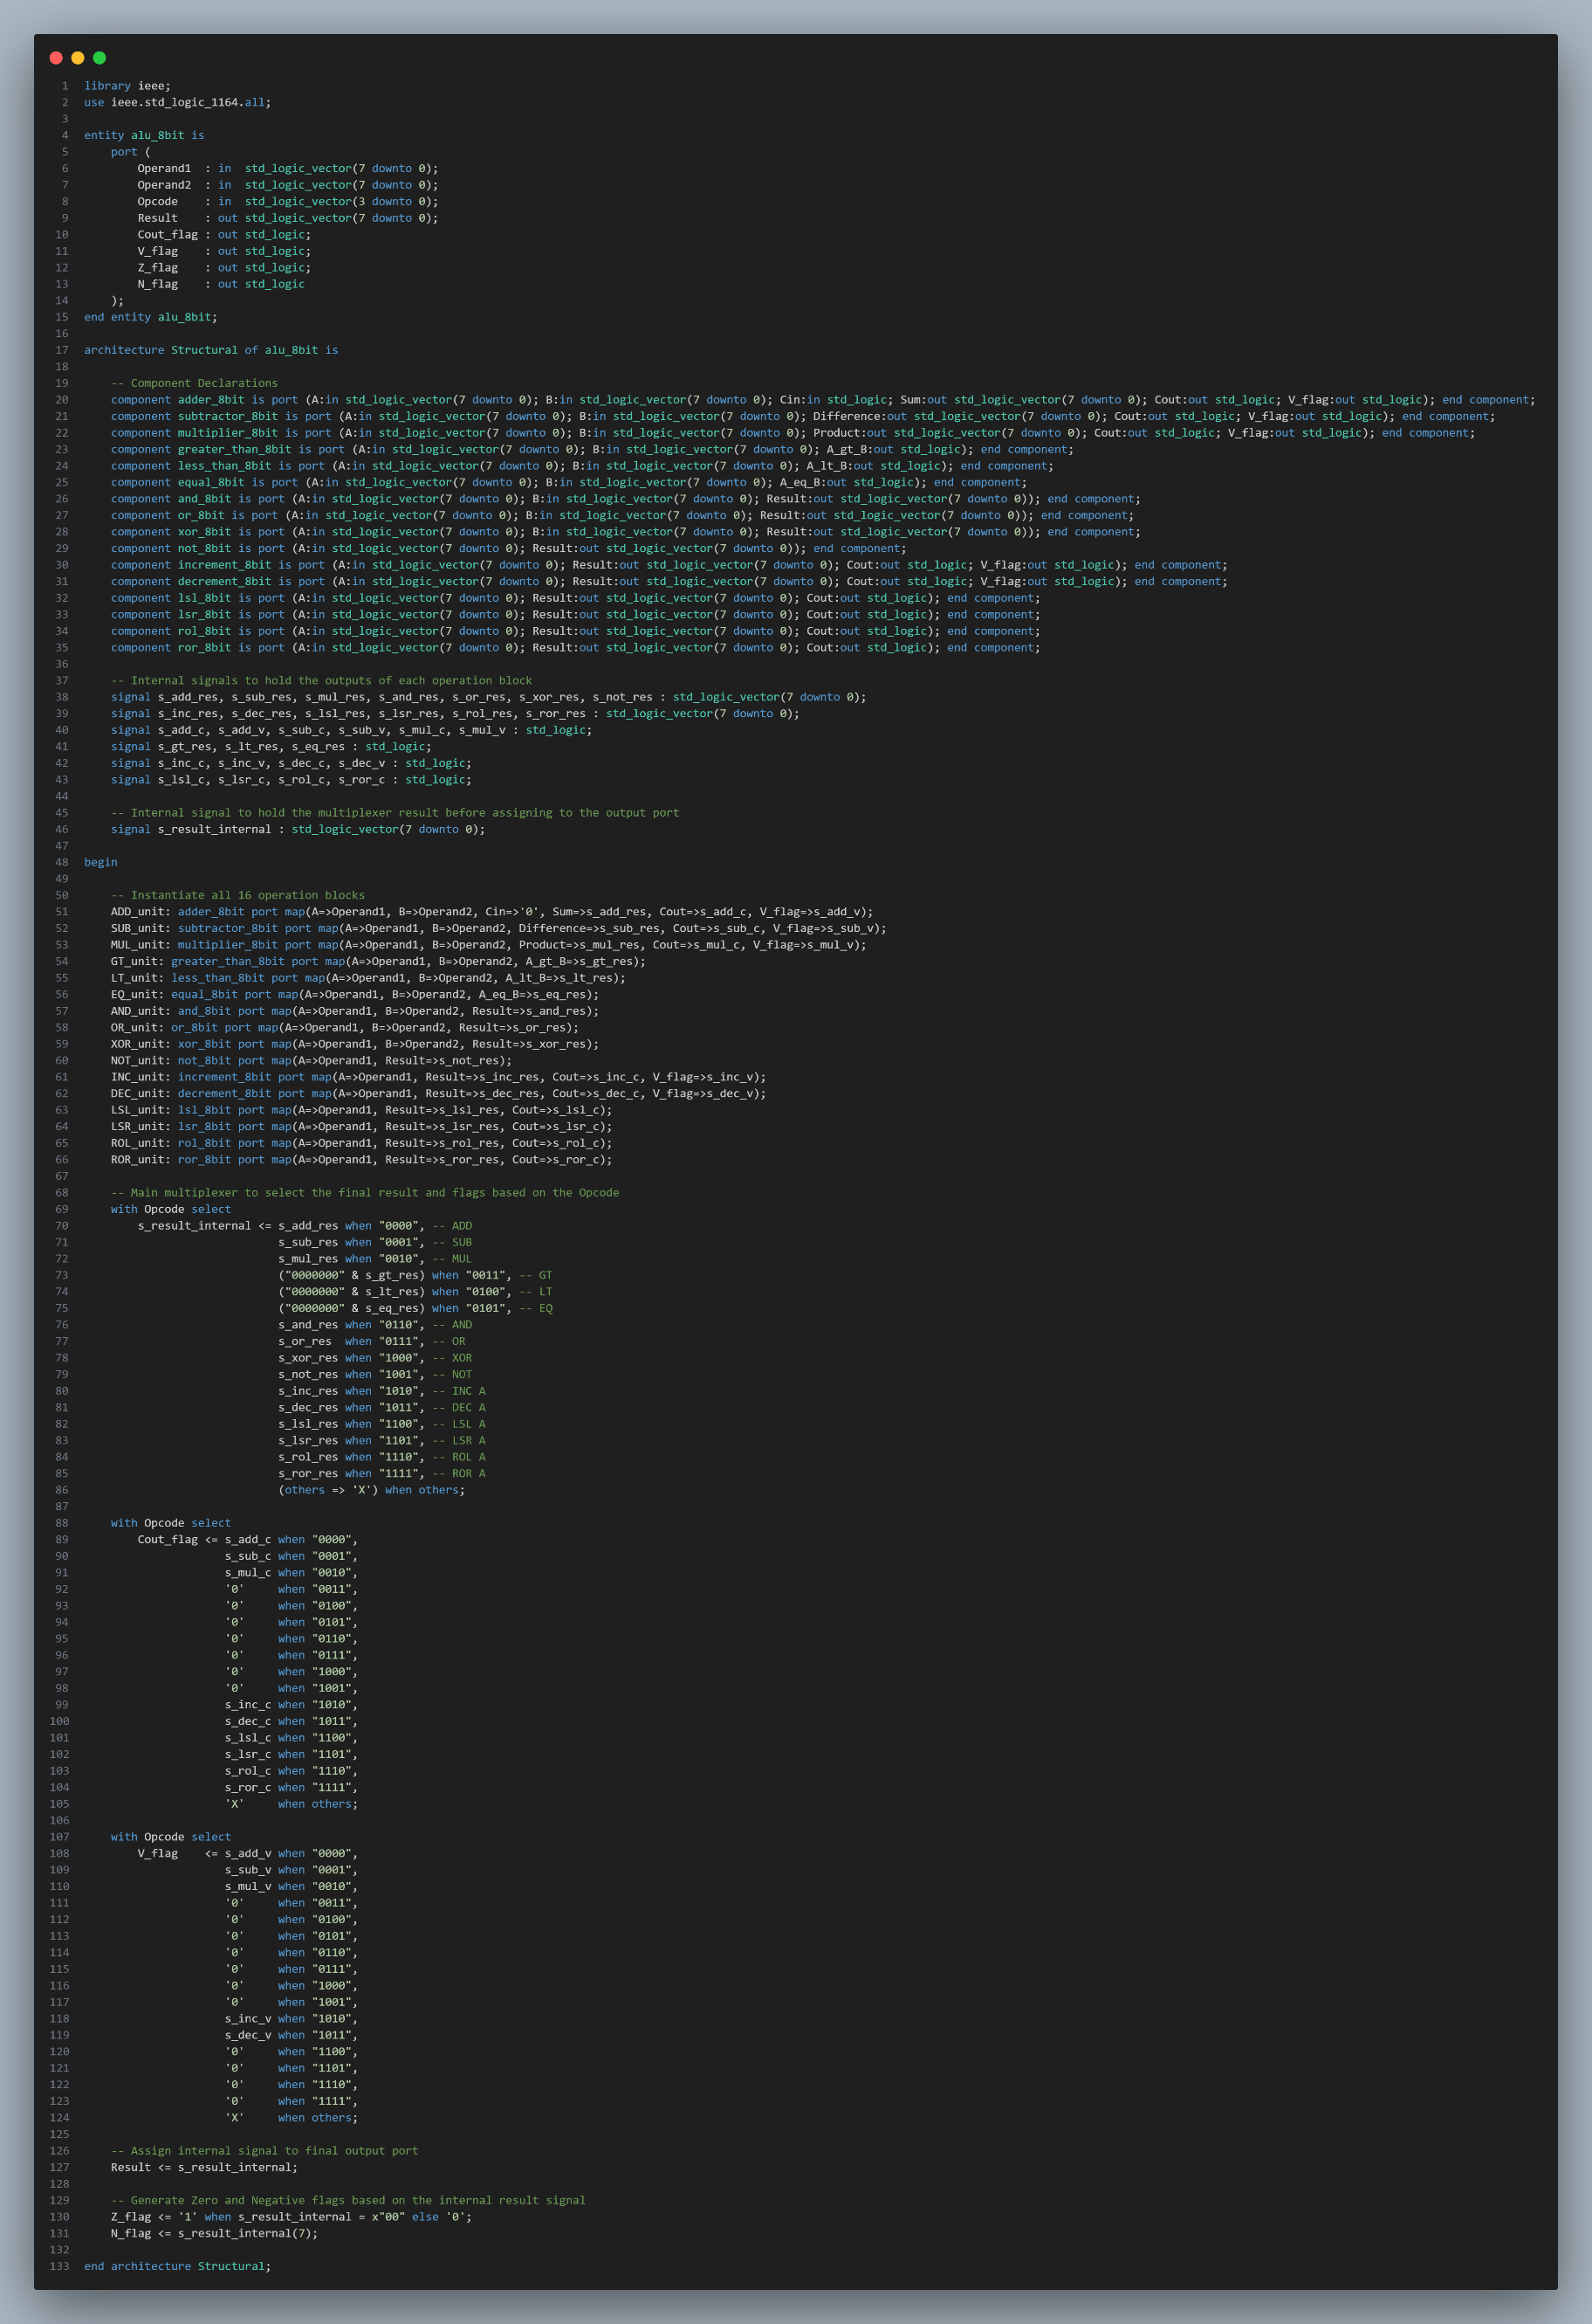

## **4.2 Register File**

The Register File is the primary high-speed storage unit within the microprocessor's datapath. It serves as a small, on-chip scratchpad memory used to hold the operands required by the ALU and to store the results of computations. The designed file consists of **8 registers**, with each register being **8 bits** wide.

To facilitate the single-cycle execution of instructions, the Register File was designed with a **dual-port read, single-port write** architecture. This configuration is critical for performance and consists of:

* Two independent **asynchronous read ports** (ReadData1, ReadData2). These ports allow the contents of any two registers, specified by ReadAddr1 and ReadAddr2, to be read simultaneously and combinationally. This enables the CPU to fetch both source operands for the ALU in the same clock cycle.
* One **synchronous write port**. A result from the ALU is written into the register specified by WriteAddr only on the rising edge of the CLK and only if the RegWrite control signal from the Control Unit is asserted. This synchronous behavior ensures that the state of the registers only changes at predictable intervals, which is essential for stable processor operation.

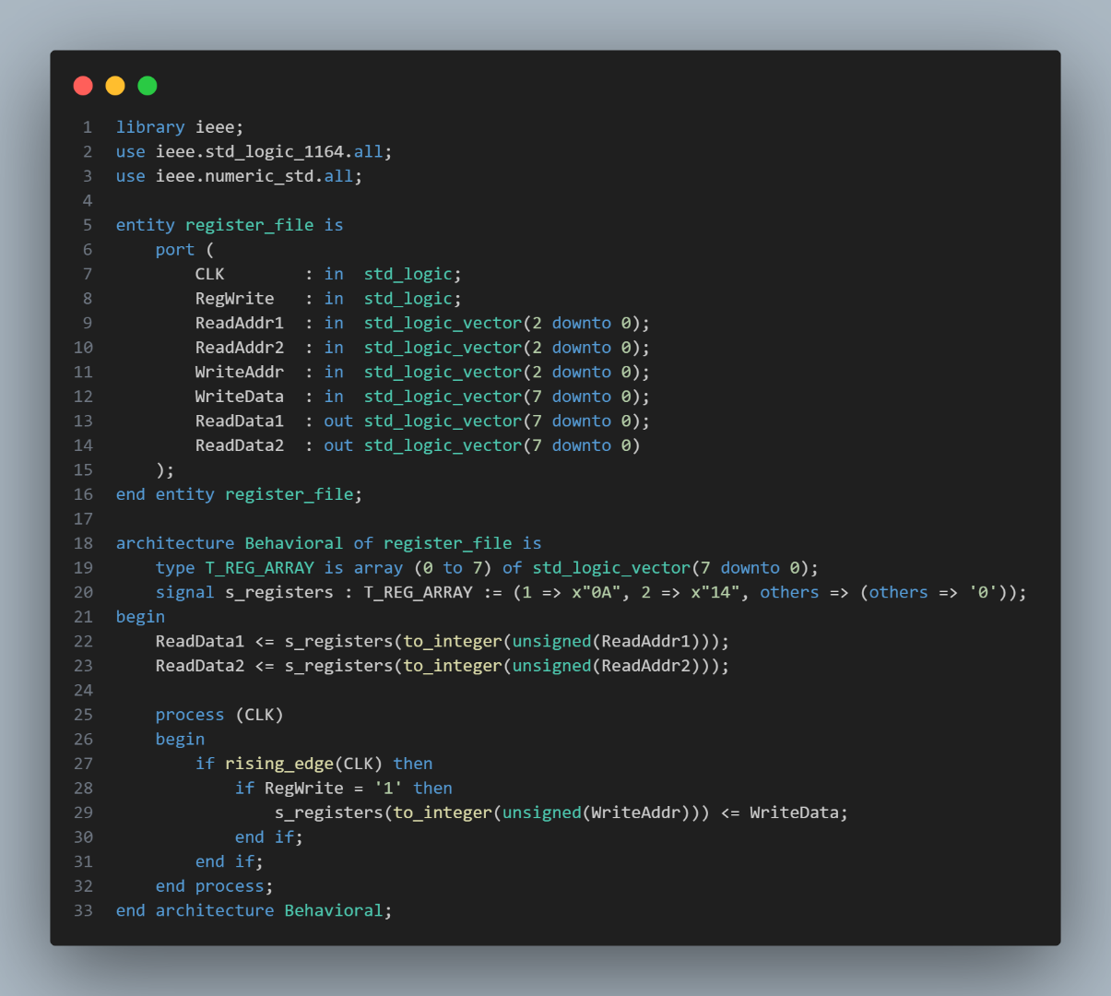

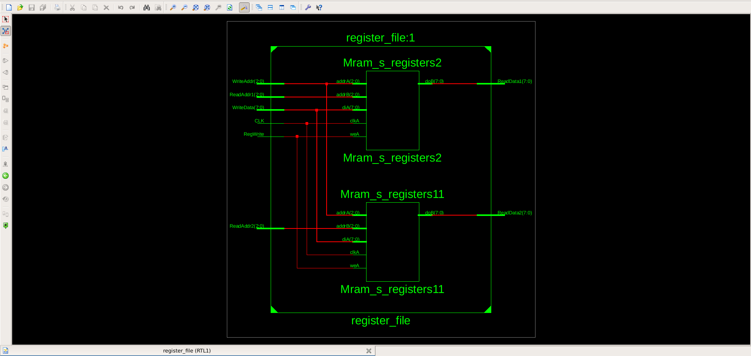In the VHDL implementation, the physical registers were modeled using an array of std_logic_vector. The asynchronous read logic was implemented using concurrent signal assignments, while the synchronous write logic was implemented within a clocked process sensitive to the rising edge of the CLK and the RegWrite enable signal.

## **4.3 Program Counter (PC)**

The Program Counter (PC) is the component responsible for controlling the flow of program execution. It is a dedicated 8-bit register whose sole function is to hold and output the memory address of the next instruction to be fetched from the Instruction ROM. Its 8-bit width allows it to address a memory space of up to 256 instructions.

The PC's operation is entirely **synchronous**, with its value updating on the rising edge of the CLK based on control signals from the Control Unit. The VHDL implementation is centered around a clocked process that prioritizes control signals in the following order:

1. **Asynchronous Reset:** A high-priority Reset signal immediately and asynchronously forces the PC's value to x"00". This ensures that the microprocessor always begins execution from the first instruction in memory upon startup.
2. **Synchronous Load:** When the PC_Load signal is asserted, the PC is overwritten with an address supplied on the Jump_Address_in port. While not fully utilized in the current design, this functionality is the essential hardware support for future jump and branch instructions.
3. **Synchronous Increment:** If PC_Load is not active but PC_Increment is, the PC's value is incremented by one. This is the default behavior for sequential instruction execution.

If none of these control signals are active, the PC holds its current value. The logic was implemented using an internal unsigned signal to facilitate the addition operation, providing a robust and predictable mechanism for program sequencing.

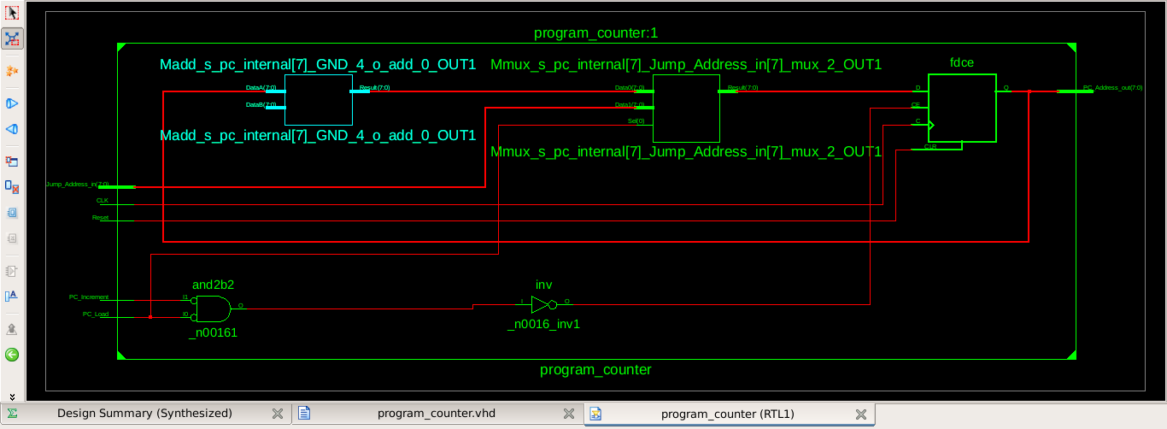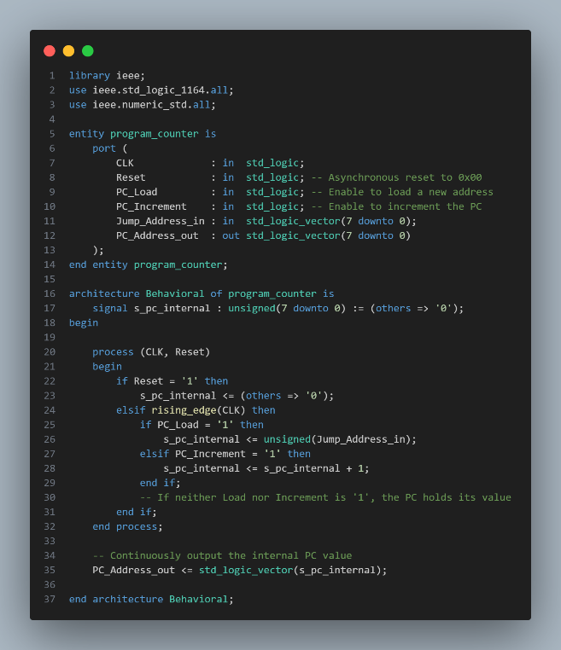

## **4.4 Instruction Memory (ROM)**

The Instruction Memory is the component that stores the program to be executed by the microprocessor. For this project, it was designed as a **Read-Only Memory (ROM)** with a capacity for 256 instructions, where each instruction is 16 bits wide. This configuration corresponds to the 8-bit address bus from the Program Counter and the 16-bit instruction width defined by the ISA.

As a ROM, its contents are fixed at design time and cannot be modified by the microprocessor during execution. Architecturally, the Instruction Memory is a purely **combinational** block; it takes an 8-bit address as an input and, after a short propagation delay, presents the corresponding 16-bit instruction on its output.

The VHDL implementation uses a **constant array** of std_logic_vector to model the memory. This is a standard, synthesizable approach for creating a ROM. The read operation is a simple, concurrent array-indexing statement. For verification, a 4-line test program was encoded according to the ISA and stored in the memory, as detailed in the memory map below.

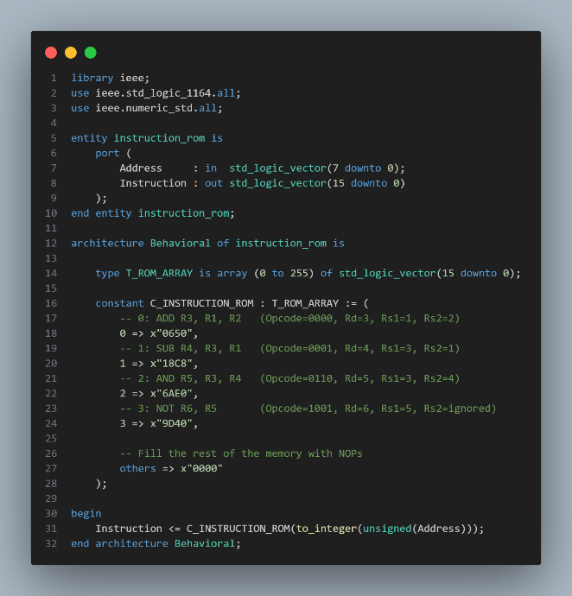

**Program Memory Map**

|  |  |  |
| --- | --- | --- |
| Address (Hex) | Machine Code (Hex) | Instruction (Assembly) |
| 0x00 | 0650 | ADD R3, R1, R2 |
| 0x01 | 18C8 | SUB R4, R3, R1 |
| 0x02 | 6AE0 | AND R5, R3, R4 |
| 0x03 | 9D40 | NOT R6, R5 |
| 0x04..0xFF | 0000 | NOP |

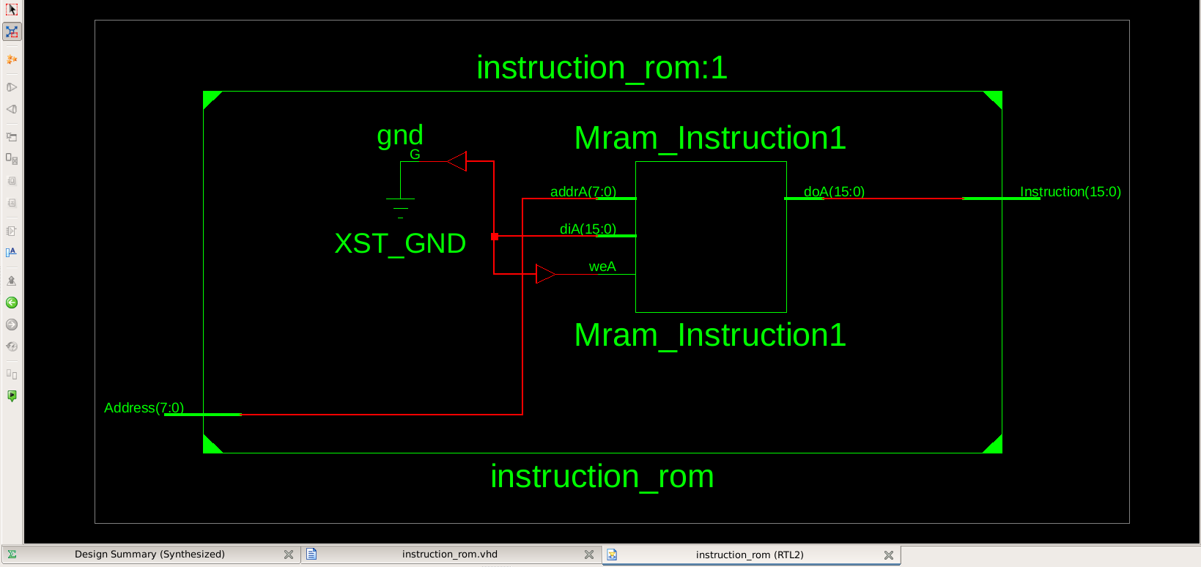

## **4.5 Status Register**

The **Status Register**, often called the flags register, is a 4-bit register that captures the outcome of arithmetic and logical operations performed by the ALU. Its primary purpose is to store this state information so that it can be used by future instructions, which is the fundamental mechanism for enabling **conditional branching** and intelligent program flow.

The register stores the four primary status flags generated by the ALU, with the following bit assignments:

* **Bit 3:** **N** (Negative flag)
* **Bit 2:** **Z** (Zero flag)
* **Bit 1:** **C** (Carry flag)
* **Bit 0:** **V** (Overflow flag)

The operation of the Status Register is fully **synchronous**. It updates its value only on the rising edge of the CLK and only when explicitly enabled by the Flags_WriteEnable signal from the Control Unit. This selective writing is critical, as it ensures that only instructions intended to affect the flags (like ADD or LSL) will modify them, while other instructions (like the comparators) will leave them unchanged. The register also includes an **asynchronous reset** to clear all flags to a known '0' state upon system startup.

The VHDL implementation consists of a clocked process that latches the 4-bit Flags_in vector into an internal signal when Flags_WriteEnable is active. This internal signal is then concurrently assigned to the Flags_out port.

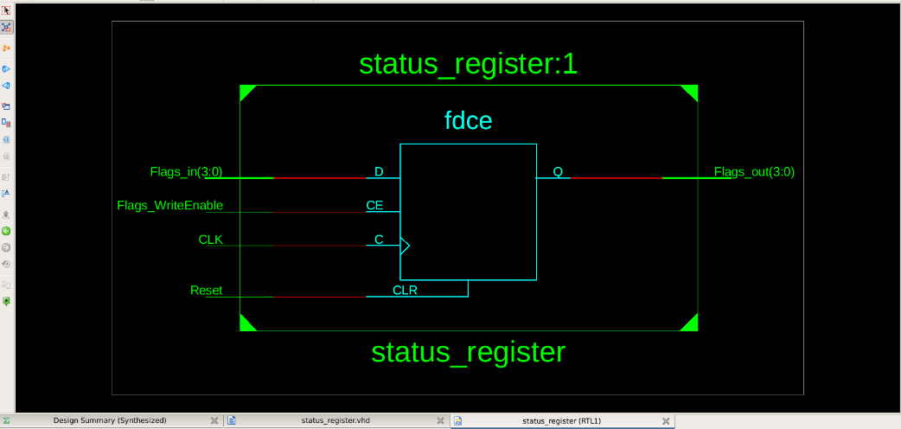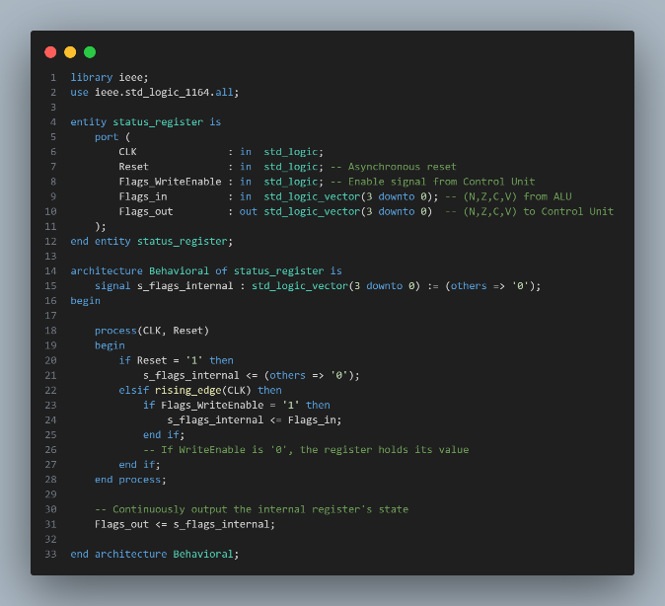

## **4.6 Control Unit**

The **Control Unit** is the central nervous system of the microprocessor. It serves as the primary **combinational** logic block that directs the operation of the entire datapath. Its fundamental purpose is to decode the instruction fetched from memory and, based on that instruction, generate all the control signals required to orchestrate the actions of the Program Counter, Register File, and ALU for a single clock cycle.

The decoding process is straightforward:

1. The Control Unit receives the 16-bit instruction word from the Instruction Memory.
2. It extracts the 4-bit **opcode** field ([15:12]) from this word.
3. This opcode is used as the input to the core decoding logic, which then asserts the appropriate output control signals.

The VHDL implementation consists of a single combinational process containing a case statement. This statement maps each of the 16 possible opcodes to a specific, hardwired set of values for the output control lines. A when others clause is included to define a safe, default state—effectively a No-Operation (NOP)—for any unused or illegal opcodes, ensuring predictable behavior. The table below illustrates the control signals generated for a few representative instruction types.

**Control Signal Mapping**

|  |  |  |  |  |  |
| --- | --- | --- | --- | --- | --- |
| Instruction (Assembly) | Opcode | ALU_Opcode | RegWrite | Flags_ WriteEnable | PC_ Increment |
| ADD R3, R1, R2 | 0000 | 0000 | 1 | 1 | 1 |
| GT R1, R2, R3 | 0011 | 0011 | 1 | 0 | 1 |
| AND R5, R3, R4 | 0110 | 0110 | 1 | 1 | 1 |
| NOT R6, R5 | 1001 | 1001 | 1 | 1 | 1 |

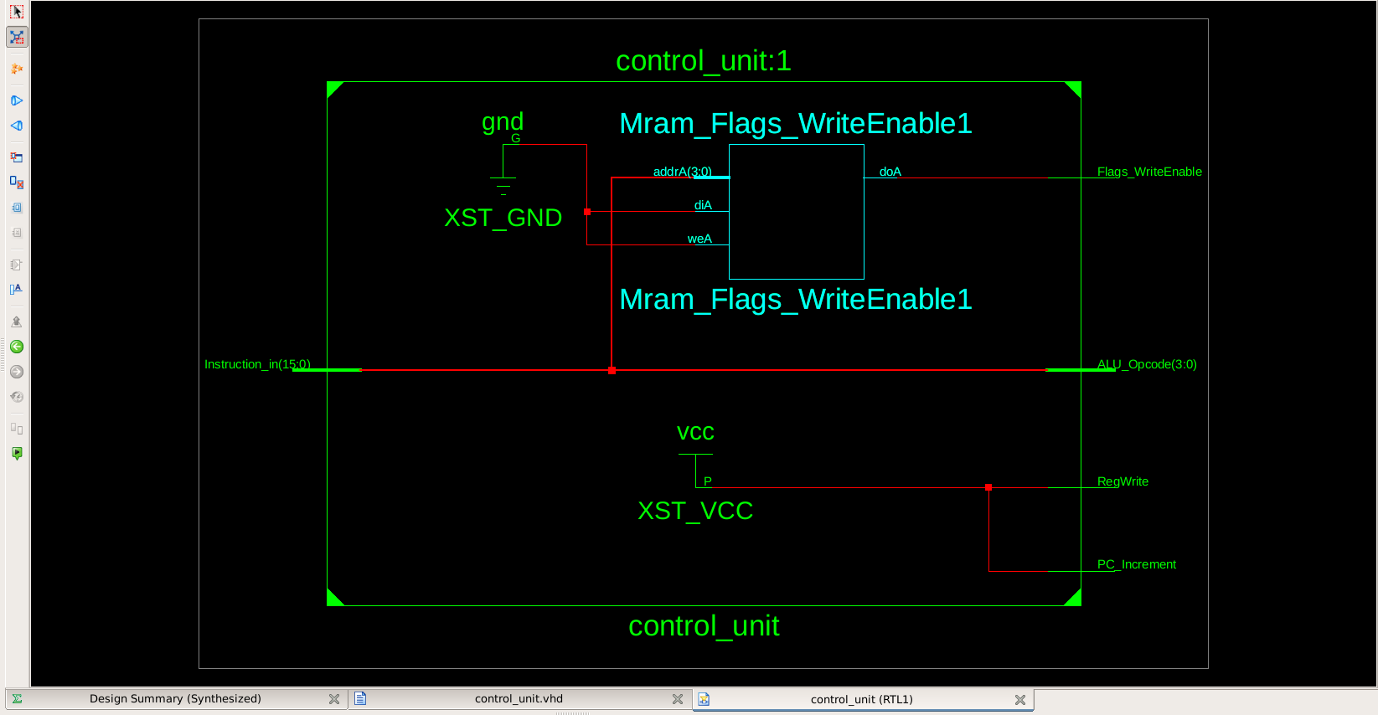

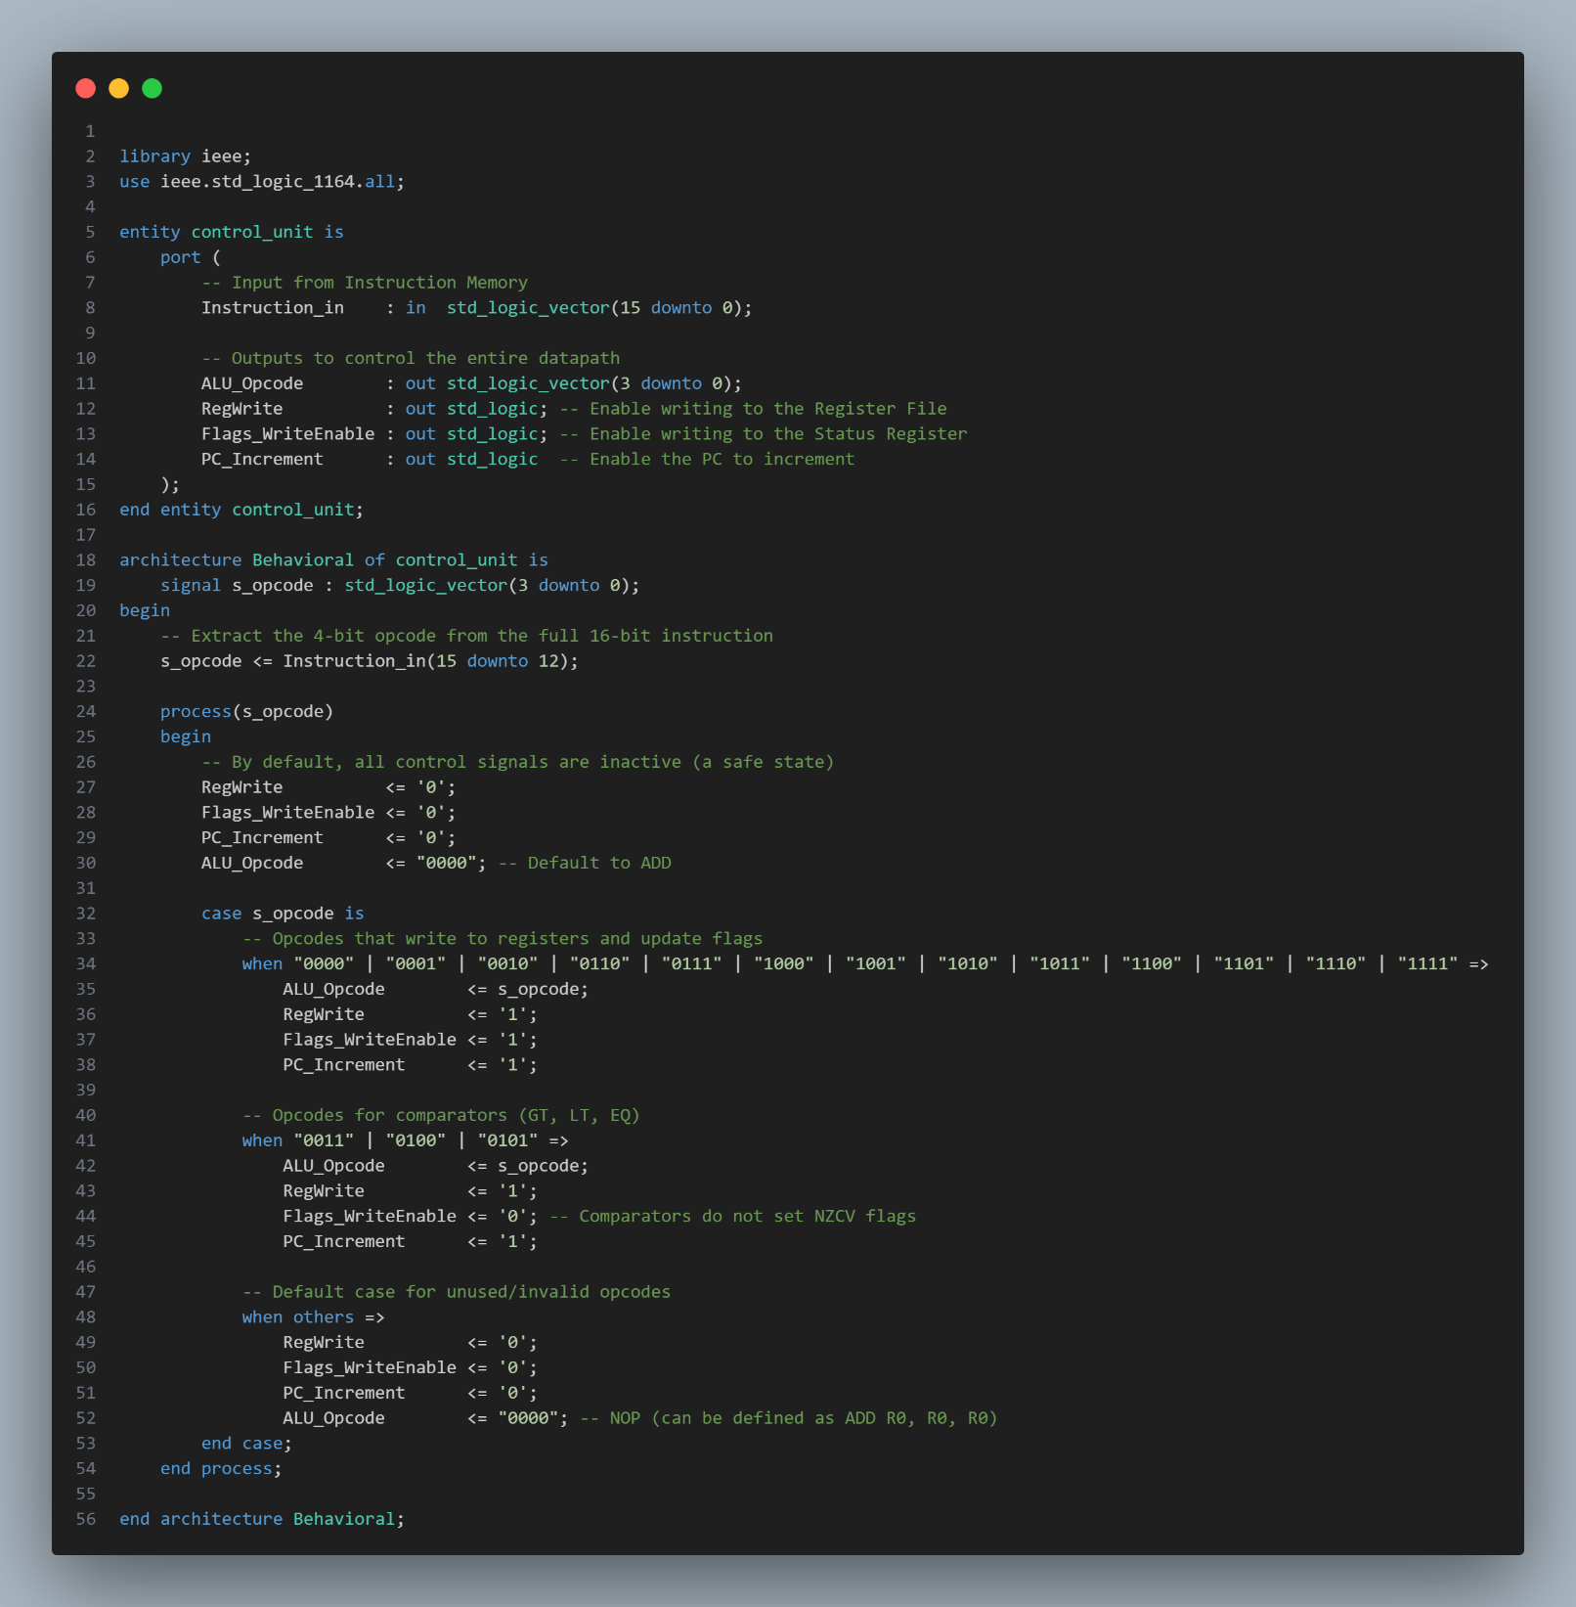

## **4.7 Top-Level Integration**

The final step in the implementation process is the top-level integration, where all the previously designed and verified hardware modules are instantiated and interconnected to form the complete microprocessor. The architecture of this top-level entity is purely structural, meaning it contains no procedural logic of its own. Instead, it consists of component instantiations and the internal signals that function as the system's data and control buses.

This module is also where the crucial **Data Forwarding** logic is implemented. By using concurrent signal assignments to create multiplexers before the ALU's inputs, this module resolves the Read-After-Write data hazard, ensuring the integrity of the datapath. The VHDL code below represents the complete and final wiring of the microprocessor.

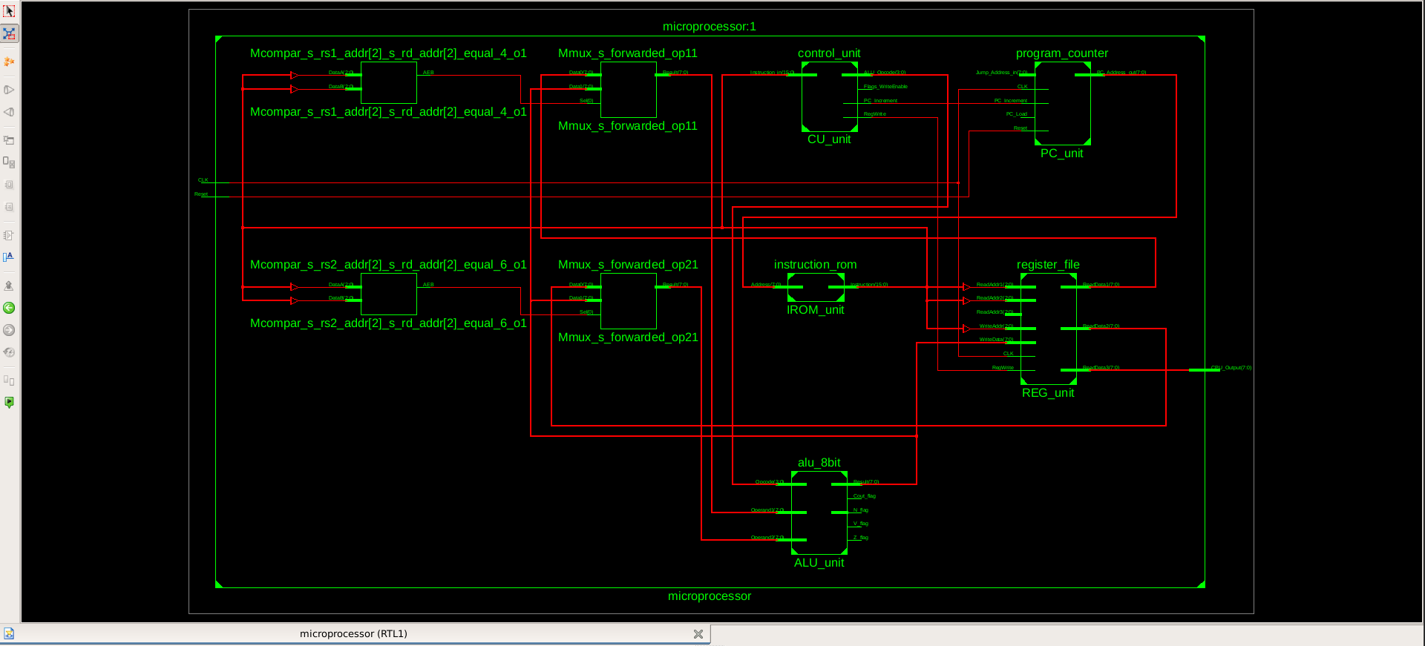

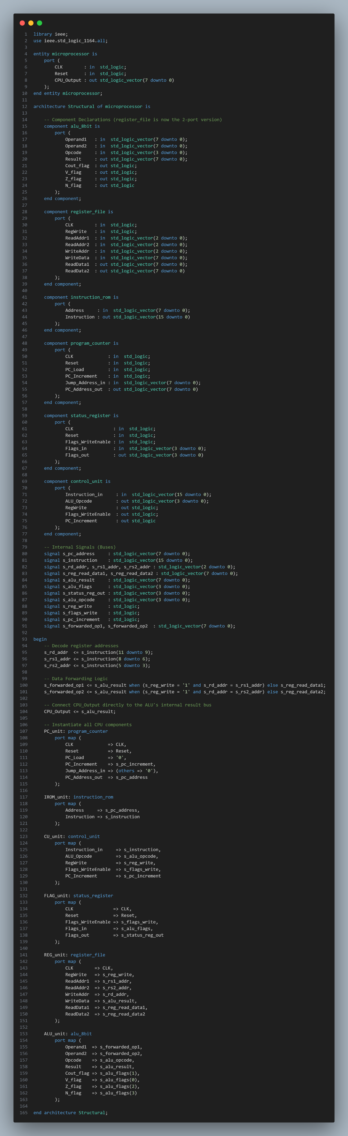

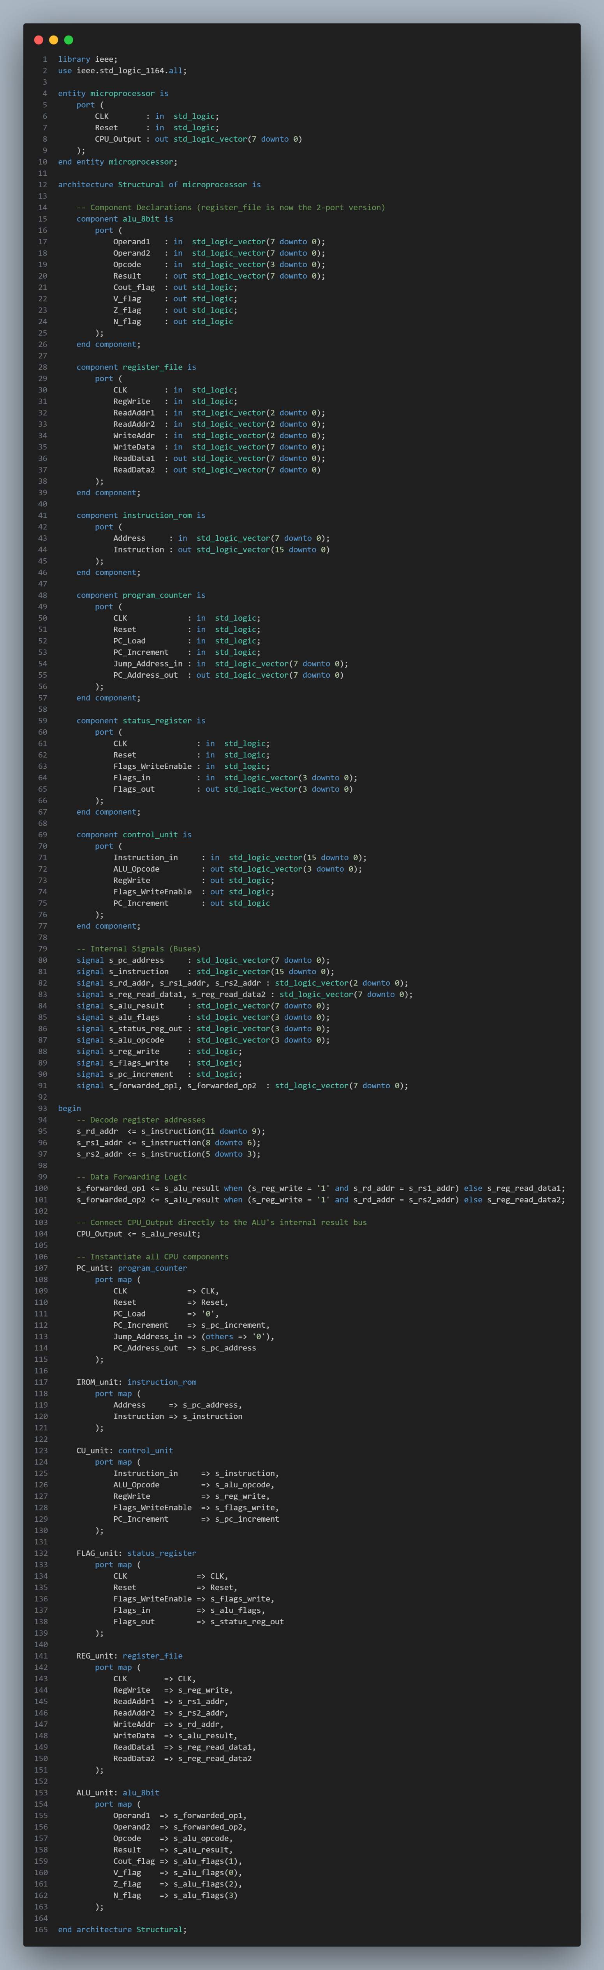

# **5.0 Verification and Testing**

Verification is a critical phase in the hardware design lifecycle, ensuring that the VHDL implementation of the microprocessor is logically correct and behaves as intended by the architectural specification. This section outlines the strategy used for simulation, the tools employed, and the results obtained from both component-level and system-level testing.

## **5.1 Simulation Strategy**

To manage the complexity of verifying a multi-component system, a systematic, **bottom-up testing** methodology was adopted. This approach involves verifying each hardware module in isolation before testing them as an integrated system, allowing for more targeted debugging and ensuring that the fundamental building blocks are robust. The entire simulation process was conducted using the ModelSim HDL simulation environment.

The strategy was divided into two primary stages:

1. **Component-Level Testing:** Each VHDL module, including the ALU, Register File, Program Counter, and Control Unit, was individually tested using a dedicated VHDL testbench. Each testbench was designed to apply a comprehensive set of input vectors that covered typical operations, boundary conditions, and edge cases specific to that module's function. The primary goal of this stage was to confirm that each component behaved correctly according to its own specification.
2. **System-Level Testing:** Once all individual components were successfully verified, the top-level microprocessor entity was tested. This integration test involved simulating the execution of a complete, multi-line program stored in the Instruction ROM. The testbench for this stage was simple, providing only the master clock and reset signals. This allowed the processor to run freely, fetching, decoding, and executing the program instructions sequentially.

For both stages, verification was performed through **manual waveform inspection**. The output signals generated by the simulation were visually compared against pre-defined verification tables to confirm that the design's behavior matched the expected outcome at each clock cycle.

## **5.2 Component-Level Simulation**

Following the bottom-up strategy, each module was tested in isolation to verify its logical correctness. For each component listed below, a dedicated VHDL testbench was developed to apply a specific set of input stimuli. The resulting output was captured in a simulation waveform and validated against a pre-defined verification table. This process ensured that each building block was fully functional before its inclusion in the top-level microprocessor design.

### **5.2.1 Arithmetic Logic Unit (ALU)**

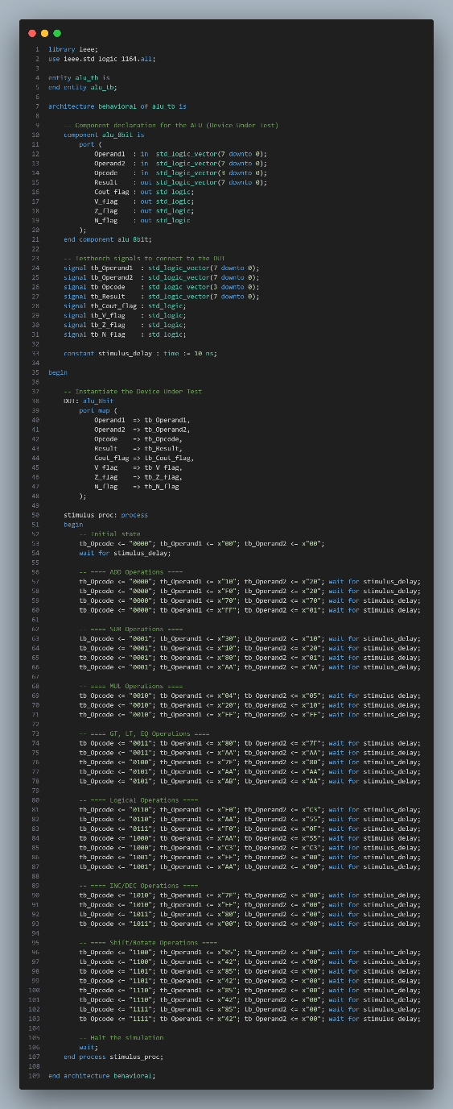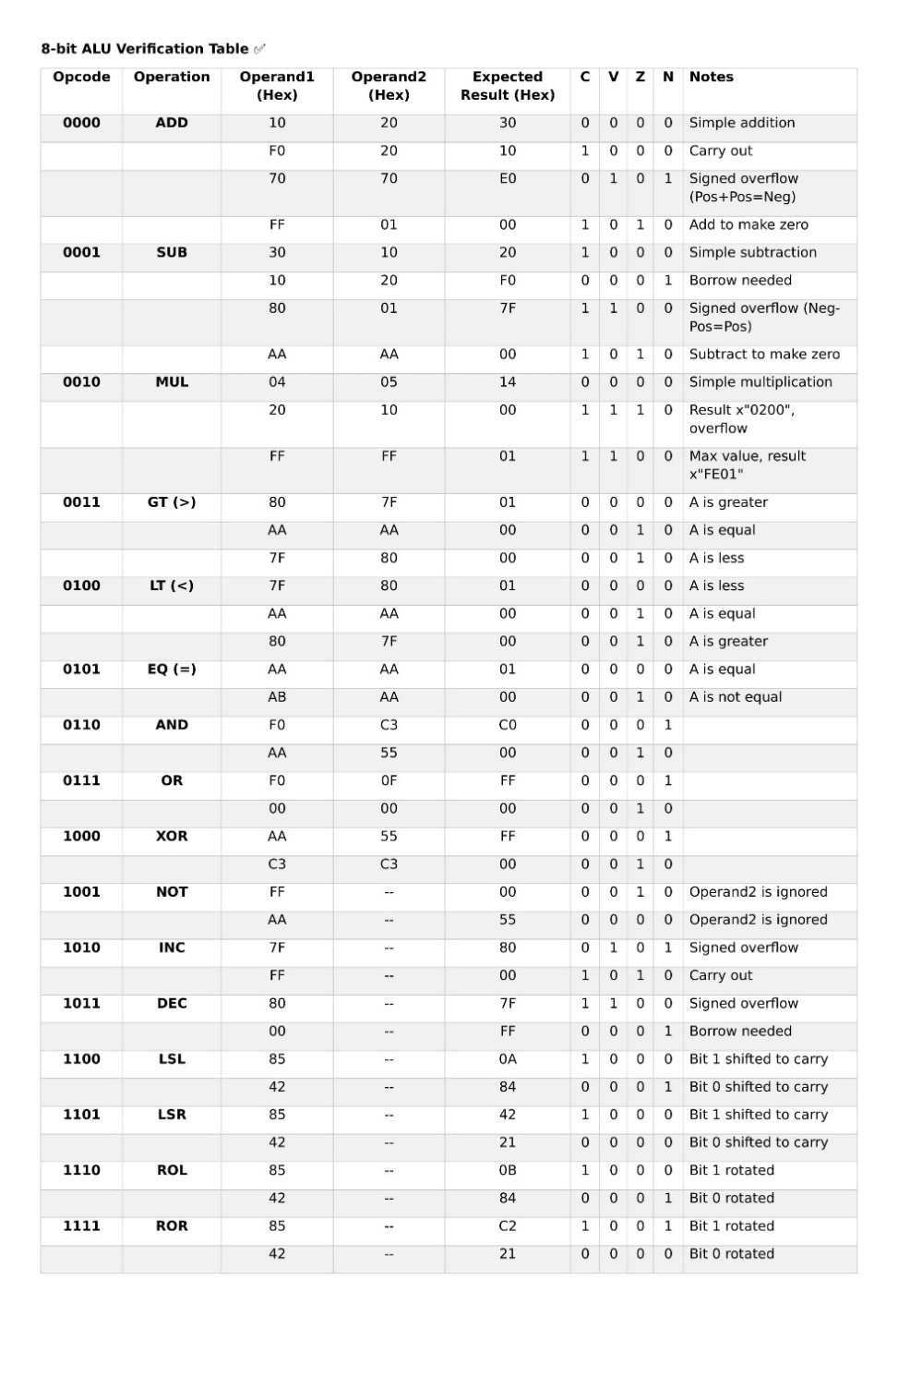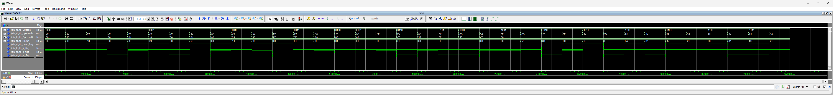The ALU was tested to confirm the correct execution of all 16 specified arithmetic and logical operations. The testbench applied a series of operand pairs designed to validate not only the 8-bit Result but also the behavior of all four status flags (N, Z, C, V). Special attention was given to edge cases, including carry generation, signed overflow conditions, and multiplication that exceeded the 8-bit result capacity.

### **5.2.2 Register File**

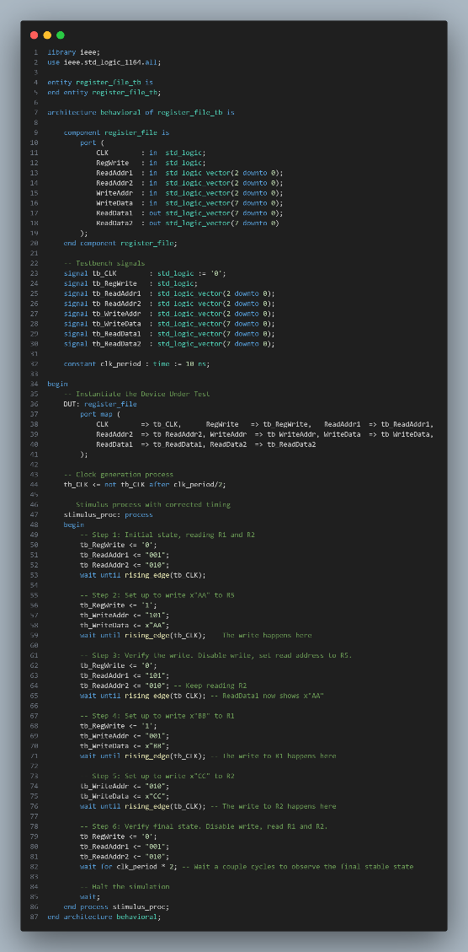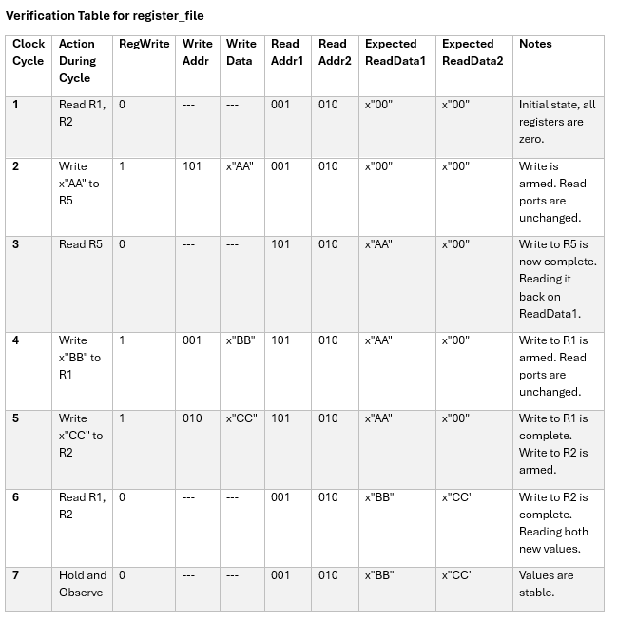The Register File was tested to verify its dual-port read and single-port write capabilities. The simulation sequence confirmed the **synchronous** nature of the write operation, data was only latched on a rising clock edge when the RegWrite signal was asserted. The test also validated the **asynchronous** behavior of the two read ports, which provided data instantaneously upon a change in the read address inputs. The test sequence involved writing distinct values to several registers and then reading them back simultaneously to ensure data integrity.

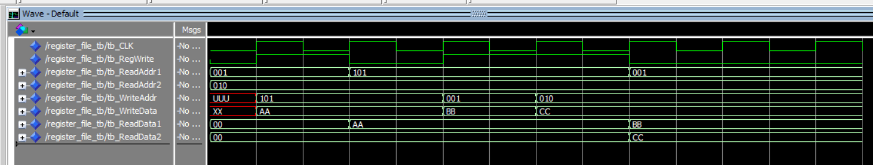

### **5.2.3 Instruction Memory (ROM)**

The Instruction Memory test was designed to confirm that the correct 16-bit instruction word was output for a given 8-bit address. The testbench sequentially provided the memory addresses corresponding to the pre-loaded 4-line program. The resulting Instruction output on the waveform was compared against the program's memory map to verify that the machine code was stored and read back correctly.

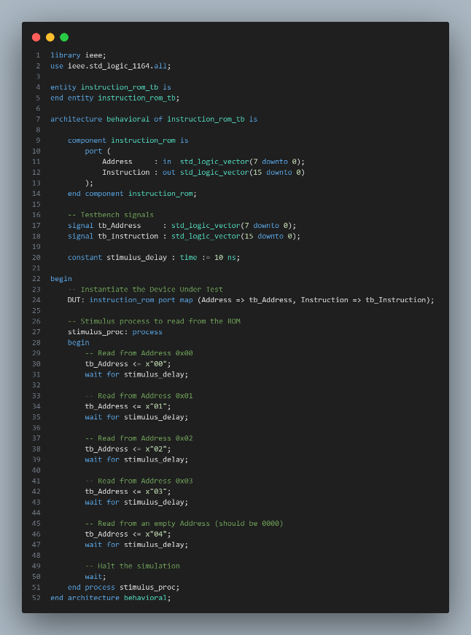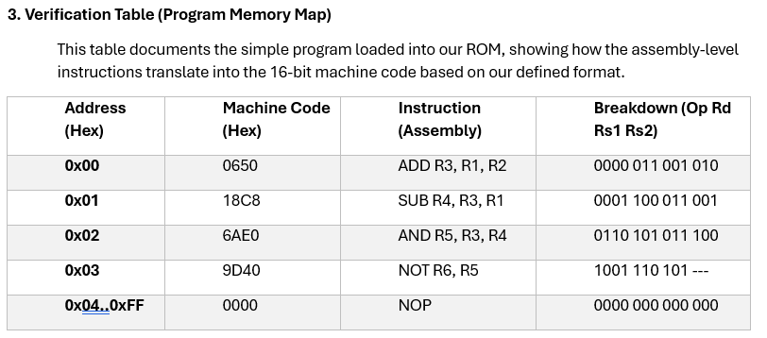

### **5.2.4 Program Counter (PC)**

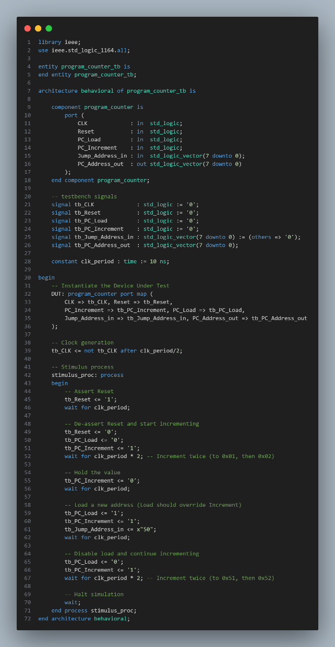The Program Counter was tested to validate its four primary functions: asynchronous reset, synchronous increment, synchronous load, and hold. The simulation sequence verified that the PC correctly resets to x"00", increments sequentially when enabled, holds its value when disabled, and that the PC_Load signal correctly overrides the PC_Increment signal to facilitate jumps.

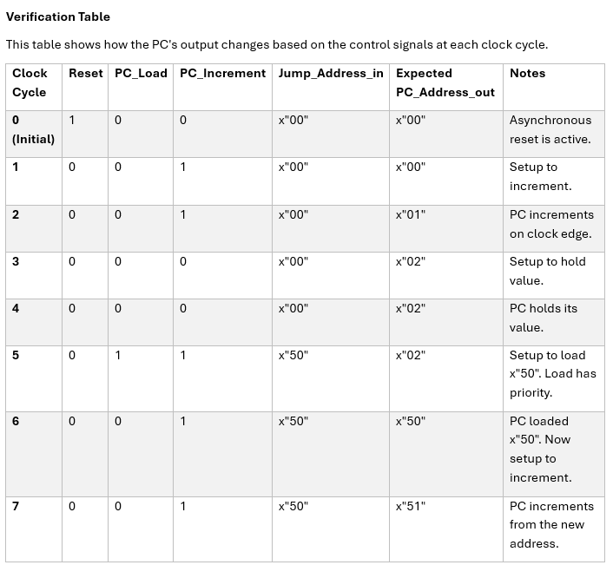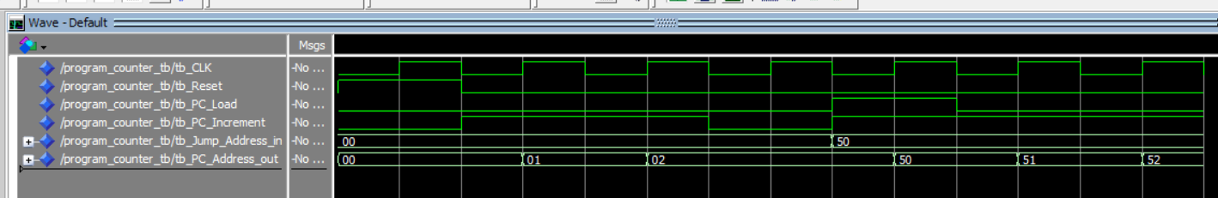

### **5.2.5 Status Register**

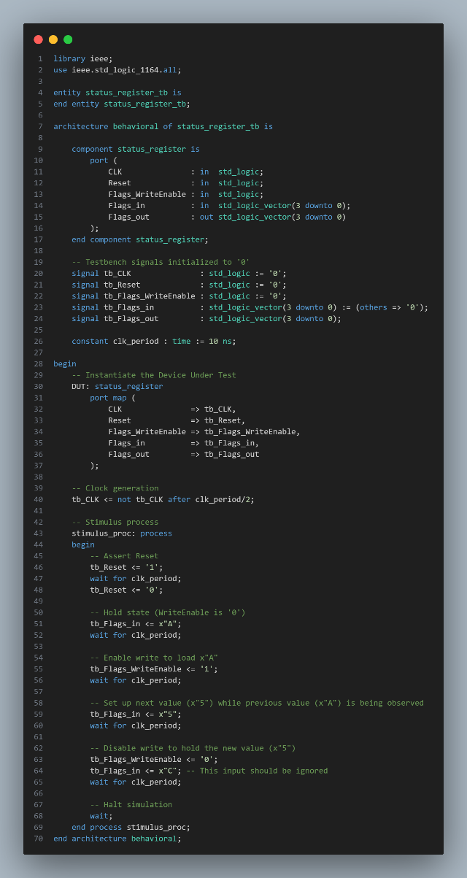The 4-bit Status Register was tested to confirm its ability to correctly load and hold the NZCV flag vector. The test sequence verified that the register's contents updated on the rising clock edge only when the Flags_WriteEnable signal was active, held its previous state when the enable was inactive, and was cleared to x"0" by the asynchronous reset.

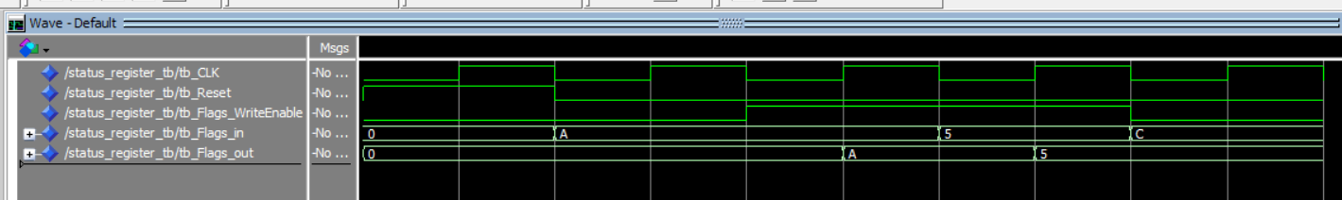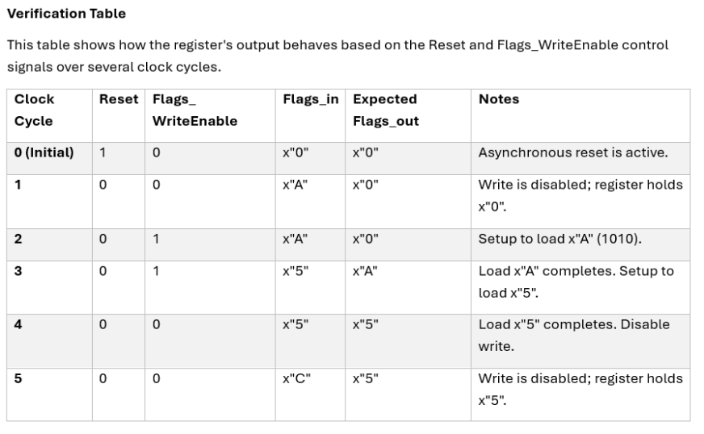

### **5.2.6 Control Unit**

The Control Unit's combinational decoding logic was tested by providing a series of sample 16-bit instructions to its input. The simulation waveform was then inspected to verify that the unit produced the correct pattern of output control signals (ALU_Opcode, RegWrite, Flags_WriteEnable, etc.) for each instruction type. The test also included an invalid opcode to confirm that the unit reverted to a safe, default state.

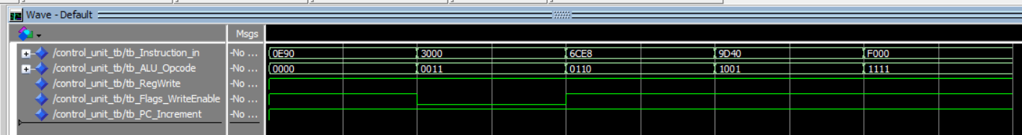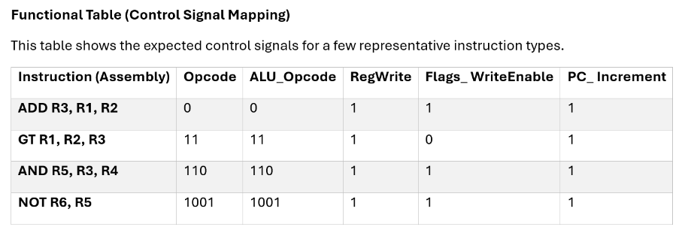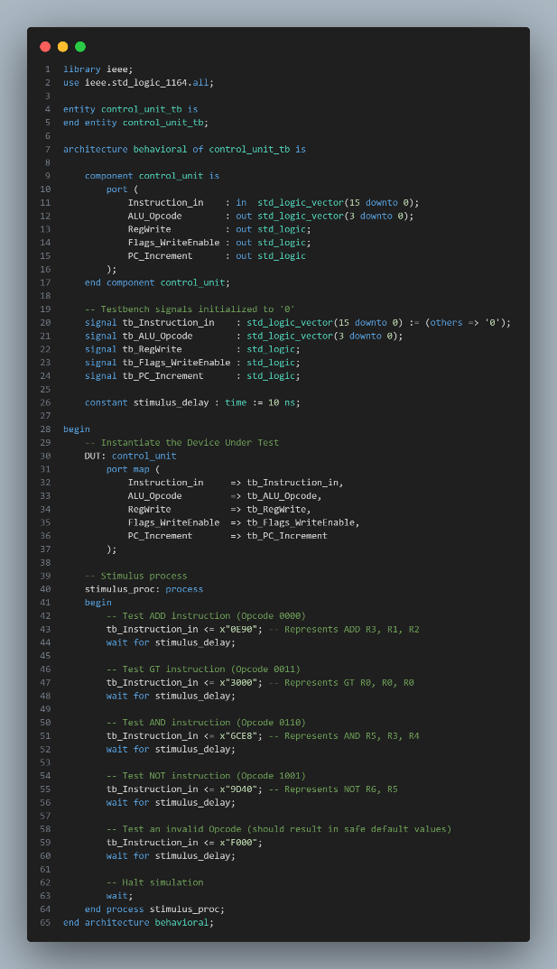

## **5.3 Top-Level System Simulation**

The final stage of verification is the **system-level integration** test. The purpose of this test is to confirm that all the individually verified modules—the ALU, Register File, PC, Instruction Memory, Status Register, and Control Unit—operate together correctly as a cohesive microprocessor. This test validates the entire datapath, the control signal distribution, and the critical timing of the integrated design.

The test procedure involved simulating the complete, top-level microprocessor entity. To provide initial data for the program, the Register File was pre-initialized with R1 = x"0A" and R2 = x"14". The system-level testbench then supplied a master clock and an initial reset pulse, allowing the processor to begin fetching and executing the 4-line **test program** stored in its Instruction ROM.

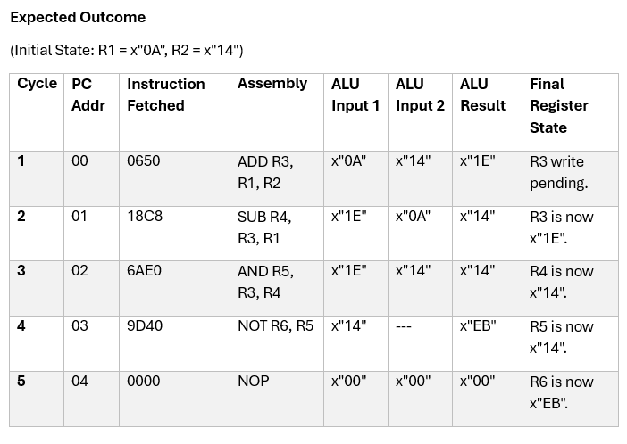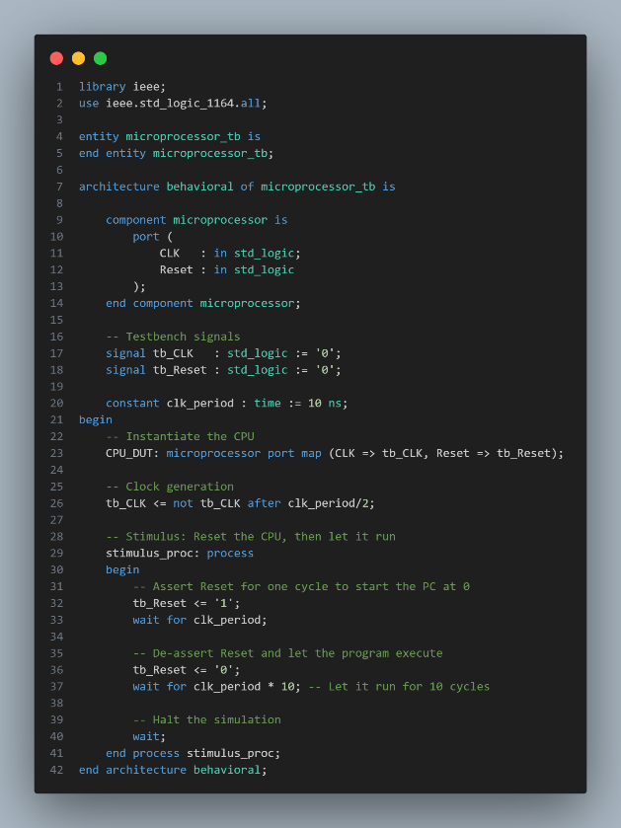Verification was performed by observing the state of the key internal buses and control signals in the ModelSim waveform viewer. The correctness of the program's execution was confirmed by comparing the simulation output, cycle by cycle, against the detailed **System Verification Table** presented below. The simulation results precisely matched the expected values, thus successfully validating the final microprocessor design, including the data forwarding mechanism that resolved the data hazard.

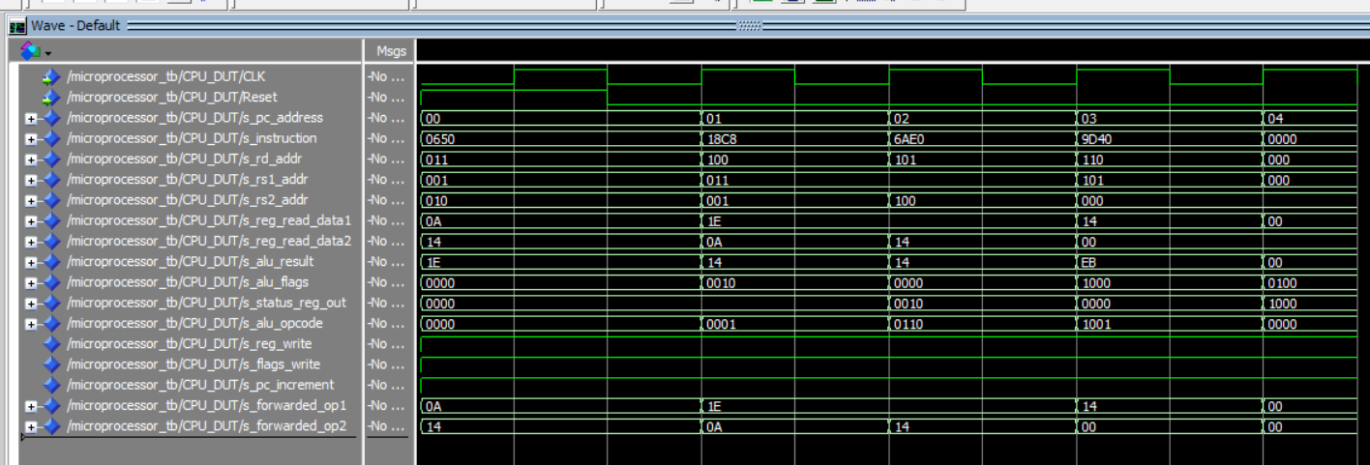

# **6.0 Discussion and Challenges**

## **6.1 Analysis of Results**

The simulation results obtained from the top-level system test successfully validated the logical and architectural correctness of the 8-bit microprocessor design. The cycle-by-cycle trace of the internal buses and control signals, as observed in the final waveform, precisely matched the predicted values in the system verification table. This successful test confirms several key aspects of the design: the datapath components (ALU, Register File, PC) interact correctly; the Control Unit generates the proper control signals for each instruction in the test program; and the overall program flow is managed as intended.

Crucially, the successful execution of back-to-back dependent instructions (such as the SUB instruction using the result of the preceding ADD) validates the implementation of the data forwarding mechanism. The results demonstrate that the processor can correctly handle Read-After-Write data hazards, ensuring program integrity.

## **6.2 Key Challenges and Solutions**

Two significant challenges were encountered during the integration and testing phase, both of which are common in processor design and provided valuable learning experiences.

* **Read-After-Write (RAW) Data Hazard:** The most critical architectural challenge was a RAW data hazard. The initial integrated simulation revealed that an instruction was attempting to read an operand from the Register File before the result of the previous instruction had been written back. This timing conflict caused the ALU to receive stale data, leading to a cascade of incorrect calculations. The solution was to implement a **Data Forwarding** path. This hardware modification creates a "shortcut" that bypasses the Register File, sending the ALU's result from the end of one cycle directly back to its inputs for the start of the next, ensuring the most current data is always available.
* **Machine Code Encoding Errors:** A persistent issue during debugging was the manual translation of assembly instructions into their 16-bit hexadecimal machine code equivalents for the Instruction ROM. Initial simulation failures were traced not to hardware logic errors, but to faulty "software." The processor was correctly executing the flawed instructions it was given. This was resolved through a meticulous, bit-by-bit re-verification of all machine code values against the defined ISA. This challenge highlighted the critical importance of verifying the test program itself with the same rigor as the hardware design.

## **6.3 Design Trade-offs**

The primary architectural decision for this project was the implementation of a **single-cycle architecture**. This choice carries significant trade-offs between design simplicity and performance.

* **Advantages:** The main benefit of the single-cycle approach is its simplicity. The control logic is purely combinational, which makes it significantly easier to design, implement, and debug. Each instruction has a clear and self-contained execution path within one clock cycle, making the overall data flow easy to trace and understand.
* **Disadvantages:** The primary drawback is performance inefficiency. The **clock period** for the entire processor must be long enough to accommodate the single slowest instruction (e.g., multiplication). This means that faster instructions (such as a simple AND or ADD) complete their work early but must wait for the full clock cycle to finish, wasting valuable processing time. This design is therefore not suitable for high-performance applications.

For the educational goals of this project, the single-cycle architecture was the optimal choice, prioritizing clarity of design and fundamental principles over performance optimization.

# **7.0 Conclusion and Future Work**

## **7.1 Conclusion**

This project successfully achieved its primary objective: the complete design, implementation, and verification of a custom 8-bit, single-cycle microprocessor. Through a modular, bottom-up methodology using VHDL, all core components—including a 16-function ALU, an 8x8 register file, a program counter, and a combinational control unit—were developed and individually tested. These components were then successfully integrated into a top-level design based on a custom 16-bit ISA.

The final system-level simulation confirmed the processor's ability to correctly fetch, decode, and execute a sequence of instructions. Key architectural challenges, such as the Read-After-Write data hazard, were identified and successfully resolved with a data forwarding mechanism, demonstrating a practical application of fundamental computer architecture principles. The project concludes with a fully functional and verifiable VHDL model of a microprocessor, which serves as a robust and well-documented foundation for further study and enhancement.

## **7.2 Future Work and Enhancements**

While the current design is a complete single-cycle processor, its capabilities can be significantly expanded. The modular nature of the design provides a clear path for the following future enhancements:

* **Data Memory and I/O:** The most critical next step is the implementation of a dedicated data memory (RAM). This would involve adding LOAD and STORE instructions to the ISA and expanding the control unit to manage memory read/write operations, allowing the processor to work with larger data sets.
* **Advanced Control Flow:** The functionality could be greatly improved by adding control flow instructions. This includes:
  + **Conditional Branches** (BEQ, BNE, etc.) that use the Status Register flags to make decisions.
  + **Unconditional Jumps** (JMP) to alter the program sequence.
  + A **Stack Pointer** and CALL/RETURN instructions to enable subroutines.
* **Architectural Improvements:** To overcome the performance limitations of the single-cycle design, the architecture could be evolved:
  + **Multi-Cycle Architecture:** Redesigning the processor to allow different instructions to take a variable number of clock cycles, improving overall efficiency.
  + **Pipelining:** Implementing a multi-stage pipeline (e.g., Fetch, Decode, Execute, Memory, Write-back) to overlap instruction execution and dramatically increase throughput.
* **FPGA Implementation:** The VHDL code for this processor is synthesizable. A logical next step would be to synthesize the design and implement it on a physical FPGA board to test its operation in real hardware.

# References

* YouTube Tutorials.
* Scribd: <https://www.scribd.com/document/470219727/A-complete-8-bit-Microcontroller-in-VHDL#:~:text=%EF%82%B7%20Condition%20Code%20Register%20,C>
* Wikipedia.org: <https://en.wikipedia.org/wiki/Arithmetic_logic_unit#:~:text=In%20computing%20%2C%20an%20arithmetic,3>
* Wikipedia.org: <https://en.wikipedia.org/wiki/Microprocessor>
* Wikipedia.org: https://en.wikipedia.org/wiki/Harvard_architecture#:~:text=The%20Harvard%20architecture%20is%20a,3
* Instructables: <https://www.instructables.com/Making-an-8-Bit-Computer/?utm_source>
* Electronicsforu : <https://www.electronicsforu.com/electronics-projects/simple-8-bit-computer-learning?utm_source>